Akademija tehničko-umetničkih strukovnih

Studija Beograd

Odsek Visoka ICT škola

Drink-Up Store

<https://drink-up-store.epizy.com/>

Smer: Internet tehnologije

Module: Web programiranje

Predmet: Web programiranje PHP 2

Student:Djordje Taskovic 188/18

Beograd, 2021

# Sadrzaj

Uvod 4

Koriscene Tehnologije 5

Koriscena Okruzenja 5

Opis funkcionalnosti 5

Dinamički meni 5

Admin Panel 5

Proizvodi 5

Single-page stana 5

Stranicenje 5

Kontakt 5

Registracija i logovanje 6

Korpa 6

Template 6

Korisceni plugin fajovi 6

Organizacija 7

Organizaciona Sema Sajta 7

7

Organizaciona sema baze 7

Mapa Sajta 8

Opis stranica sajta 9

Home 9

Store 15

Contact 16

Korpa 17

Login 18

Register 19

Single-page 20

Admin Panel 21

Blogs link 22

Users link 23

Contact Messages link 24

Orders link 25

Create Product link 26

Update link 27

Author 28

Struktura projekta 29

Kodovi Sajta 32

Php 32

Rutes/web.php 32

CartController 34

ContactController 36

FormController 37

HomeController 40

OsnovniController 41

ProductController 41

LogMiddleware 45

MessageRequest 45

ProductStoreRequest 46

ProductUpdateRequest 47

UserInputRequest 49

Availability 50

Blog 50

Category 50

Image 51

Menu 51

Order 52

Product 52

Blade fajlovi 55

Admin-panel/fixed 55

Head 55

Navbar 56

Scripts 57

Sidebar 57

Admin-panel/pages 58

Blogs 58

Dashboard 59

Messages 62

Orders 63

User 64

Admin-panel/route 66

Admin-panel-layout 66

Deoproduct/ 66

Error 66

Forma 67

Product 70

Fixed/ 71

Footer 71

Head 73

Navigation 73

Scripts 75

Layouts/ 75

layout 75

Pages/ 75

Main/ 75

Author 75

Cart 78

Contact 80

Home 82

Login 86

Register 86

Products/ 86

Create 86

Edit 87

Forma 87

Index 90

Single 92

JS 94

Main.js 94

CSS 96

Style.css 96

# Uvod

## Koriscene Tehnologije

* HTML5
* CSS3
* Laravel
* Javascript
* Ajax
* Php
* Bootstrap 4

## Koriscena Okruzenja

* Visual Studio Code
* Php Storm
* Xampp
* MySql

## Opis funkcionalnosti

### Dinamički meni

Prilikom učitavanja stranice prikazuje se dinamiči meni sa odredjenim staranicama sajta kao i active linkovi sa desne strane koji prikazuje odgovarajuće linkove za admina, običnog autorizovanog ili neautorizovanog korisnika, u zavisnosti od aktivnosti i stanja korisničke uloge.

### Admin Panel

Panelu je dozvoljen pristup samo admin-u prilikom logovanja na formi sajta.

Sam panel sadrzi informacije o svim proizvodima sa sajta, informacije postavljenih blogova sajta, registrovanih korisnika, kontakt poruka poslatih od odredjenih korisnika, lista porudzbina prouizvoda za odredjenog korisnika, fungcija kreiranja novog proizvoda ,fungcija anzuriranja i brisanja postojecih proizvoda.

### Proizvodi

Sav bitan sadrzaj na sajtu je ispisan iz baze krajnim korisnicima na sajtu na stranici ’store’ kao i na strani ’home’. Na stranici ’store’ postoji dinamička lista za filtriranje proizvoda po kategoriji pica, lista za sortiranje proizvoda po ceni i nazivu i po stanju prodaje odredjenog proizvoda.

### Single-page stana

Ovoj stranici se pristupa klikom na ’lupa’ dume proizvoda. Prikazuju se podaci o proizvodu sa opsirnim opisom na posebnoj strani.

### Stranicenje

Straničenje se koristi na stanici za proizvode, za bolji prikaz usled velikog broja proizvoda.

### Kontakt

Na strani ’contact’ postoji forma za slanje pozeljne poruke ili odredjenog ’fiddbeck-a’ kreatoru sajta ili organizaciji.

### Registracija i logovanje

Na sajtu postoji registracija i logovanje korisnika. Provera podataka prilikom registracije je urađena na serverskoj i klijentskoj strani. Prilikom uspešne registracije korisnik se automatcki uloguje na sajt i dobija ulogu korisnika, koju može da menja samo administrator.

Provera podataka prilikom logovanja se vrši na serverskoj i klijentskoj strani i ako podaci nisu dobri obaveštava se korisnik gde je pogrešio prilikom logovanja.

### Korpa

Samo autorizovani korisnik može dodavati proizvode u korpu. Sistem korpe na sajtu realizovan je pomoću kreiranja ’cart’ sesije i koriscenje samih informacija.

Korisnik u korpu može da doda više proizvoda, kao i više proizvoda istog tipa. Takođe omogućeno mu je da briše proizvode iz korpe ’remove’.

Pri odabranim proizvodima korisni dobija notifikaciju pored icone ’cart’ u navigaciji o tome koliko je proizvoda izabrano.

Ako se korisnik izloguje podaci iz korpe se brisu (brise se sesija za ’cart’).

Na cart stranici korisniku se prikaziju uracunati ’subtotal’ kao i ’total’ cene za porudzbinu.

Klikom na taster ’Make an Order’ korisniku se prikazuje poruka koja ga obaveštava da je uspešno izvršio kupovinu, podaci se memorišu u bazu i prikazuju administratoru sajta o porudžbini.

### Template

Koriscen je template za kreiranje admin panela koji je modifikovan i prilagodjem porebama sajta.

## Korisceni plugin fajovi

Za potrebe sajta i same konstrukcije su koriscene klasse bootstrapa

kao i ’now-ui-dashboard’ klasa za bojlu organizaciju i prikazivanje produkta na admin panelu. Na sajtu su takodje je koriscen ’temify-icons’ set fontova za bolji izgled.

### 

# Organizacija

## Organizaciona Sema Sajta

Sa svake stranice se može pristupiti svakoj stranici (naravo u zavisnosti od uloge korisnika, običnog autorizovanog ili neautorizovanog korisnika, u zavisnosti od aktivnosti i stanja korisničke sesije).

Home

Register

Store

Author

Login

Cart

Admin_panel

Single_page

Contact

## Organizaciona sema baze

Sema baze sa svim podacima neophodnim podacima.

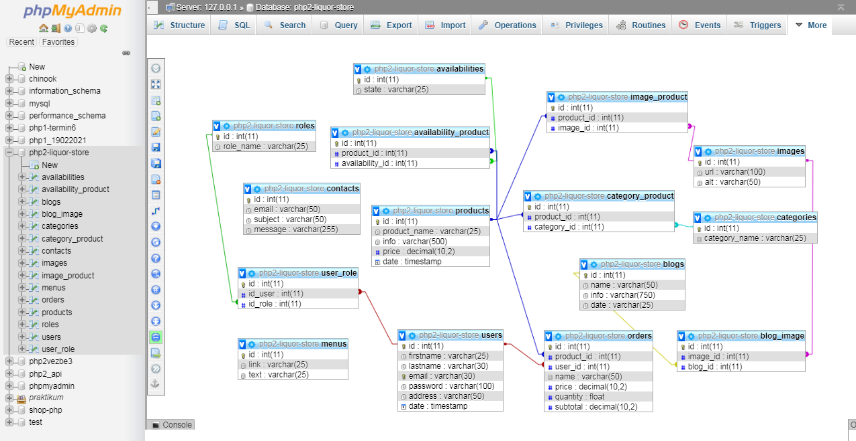

## Mapa Sajta

<?php echo '<?xml version="1.0" encoding="UTF-8"?>';?>

<urlset xmlns="http://www.sitemaps.org/schemas/sitemap/0.9">

<url>

<loc>https://drink-up-store.epizy.com/</loc>

<lastmod>2020-03-12</lastmod>

<changefreq>weekly</changefreq>

<priority>0.95</priority>

</url>

<url>

<loc>https://drink-up-store.epizy.com/home</loc>

<lastmod>2020-03-12</lastmod>

<changefreq>weekly</changefreq>

<priority>0.9</priority>

</url>

<url>

<loc>https://drink-up-store.epizy.com/store</loc>

<lastmod>2020-03-12</lastmod>

<changefreq>monthly</changefreq>

<priority>0.7</priority>

</url>

<url>

<loc>https://drink-up-store.epizy.com/contacthome</loc>

<lastmod>2020-03-06</lastmod>

<changefreq>weekly</changefreq>

<priority>0.7</priority>

</url>

<url>

<loc>https://drink-up-store.epizy.com/author</loc>

<lastmod>2020-03-12</lastmod>

<changefreq>monthly</changefreq>

<priority>0.65</priority>

</url>

<url>

<loc>https://drink-up-store.epizy.com/cart</loc>

<lastmod>2020-03-12</lastmod>

<changefreq>monthly</changefreq>

<priority>0.65</priority>

</url>

<url>

<loc>https://drink-up-store.epizy.com/loginhome</loc>

<lastmod>2020-03-12</lastmod>

<changefreq>yearly</changefreq>

<priority>0.55</priority>

</url>

<url>

<loc>https://drink-up-store.epizy.com/registerhome</loc>

<lastmod>2020-03-12</lastmod>

<changefreq>yearly</changefreq>

<priority>0.55</priority>

</url>

<url>

<loc>https://drink-up-store.epizy.com/logout</loc>

<lastmod>2020-03-12</lastmod>

<changefreq>yearly</changefreq>

<priority>0.55</priority>

 </url>

</urlset>

## Opis stranica sajta

### Home

Dinaičko učitavnje meni linkova na svim stranama.

Meni je prilagodjen za sve vrste uredjaja tako da se na manjim ekranima prikazuje „Menu”i klikom na njega se otvara meni.

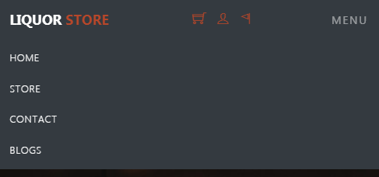

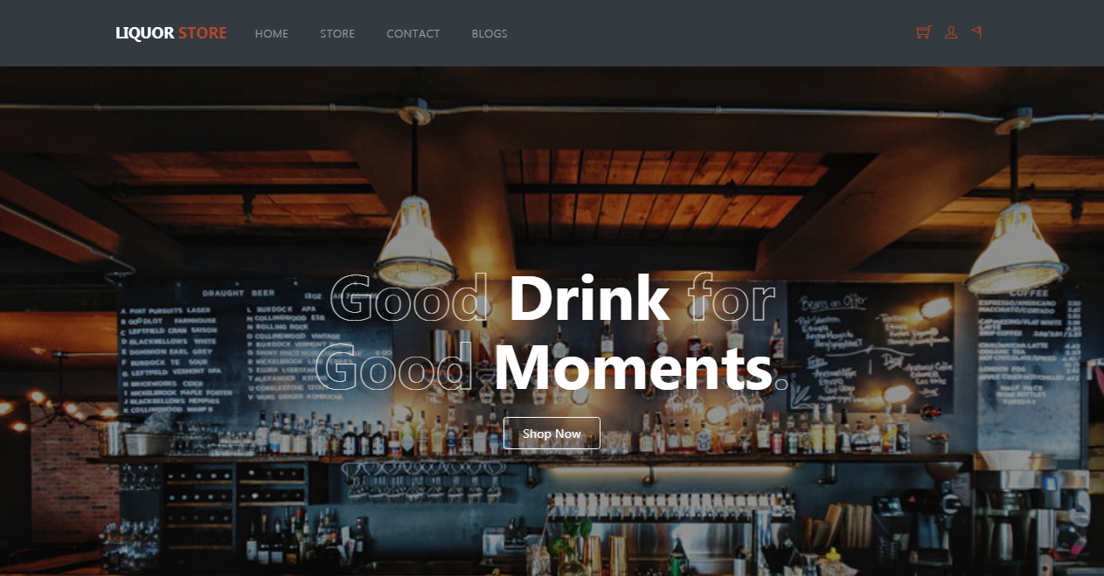

Dinamicko Prikazivanje ’banner’ sekcije na home strani sa podacima koji reklamiraju sajt proizvode. Kao i na store strani porizvodi poseduju linkove ’lupa’ i ’korpa’ za prikazivanje samostalnog itema i upisa u korpu.

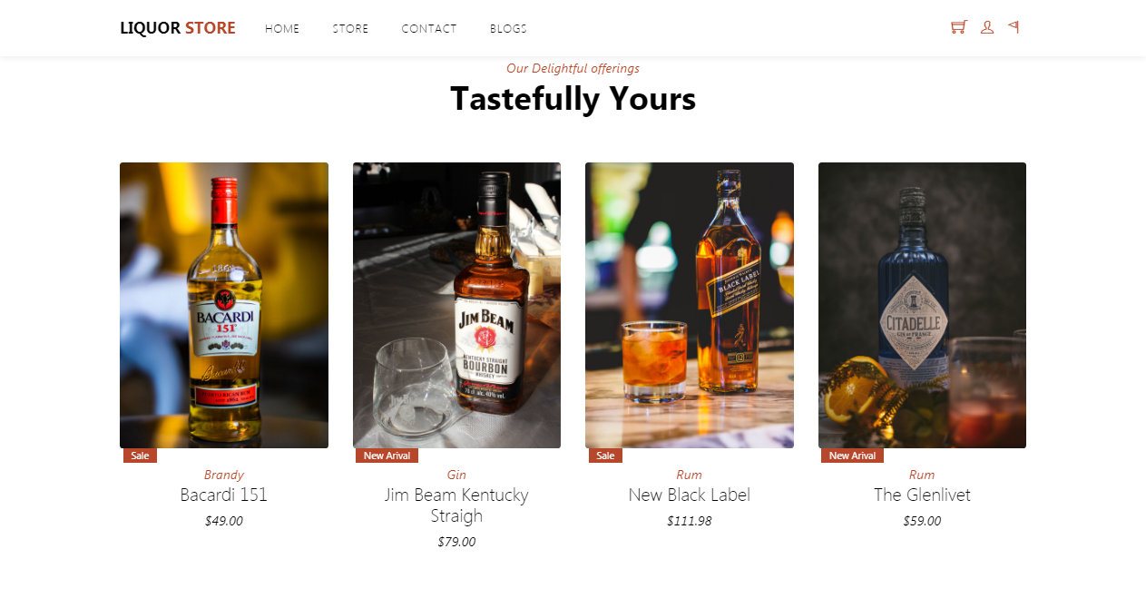

Prikazivanje about sekcije koja krajnjem korisniku dostavlja informacije o sajtu.

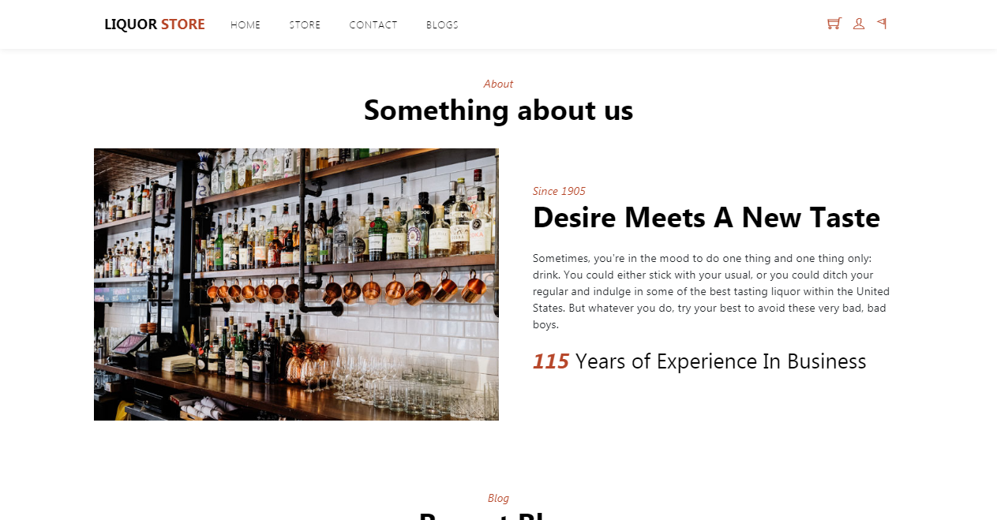

Dinamicko prikazivanje blogsekcije koja krajnjem korisniku dostavlja informacije o najnovijim vestima proizvoda kao i svepa pica.

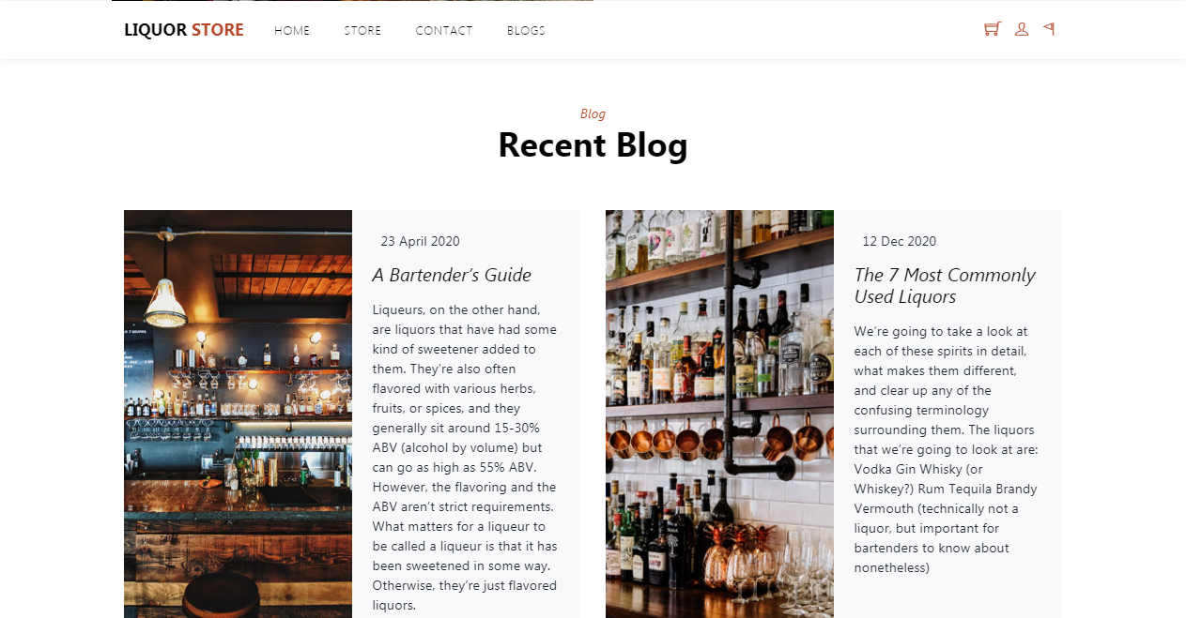

Footer sekcija sa korisnim i promovisanim linkovima.

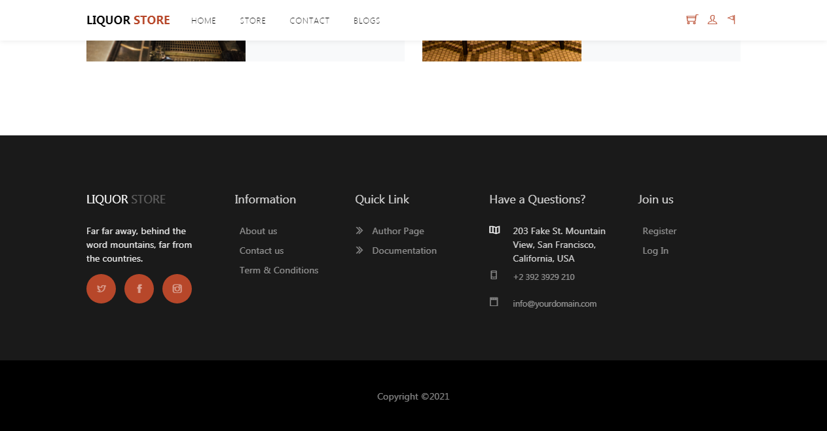

## Store

Dinamicko ispisivanje svih proizvoda na strani(na osnovi stranicenja). Pored ispisa mogucnost filtriranja producta klikom na nekih od kategorija sa leve strane kao i fungcionalnost sortiranja istih klikom na sort by price. Pored toga omogucena je i pretraga odredjenog itema po nazivu i stanju item-a.

Kao i na home strani porizvodi poseduju linkove ’lupa’ i ’korpa’ za prikazivanje samostalnog itema i upisa u korpu.

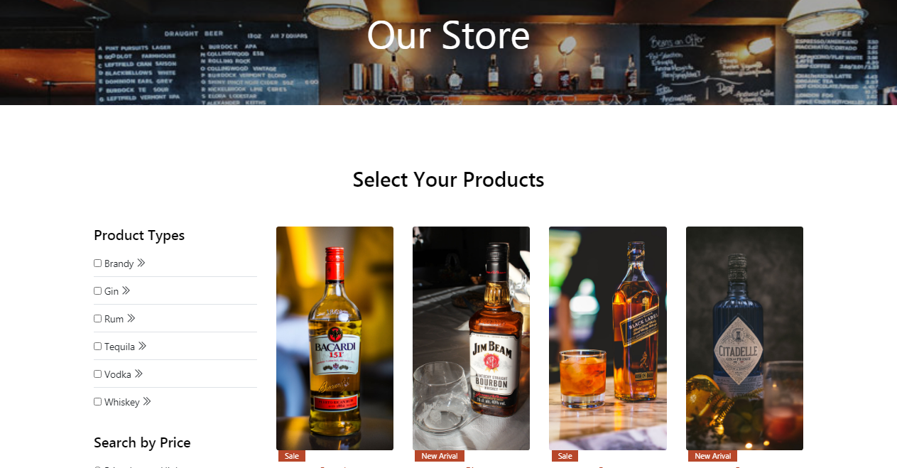

## Contact

Kontakt sekcija sa podacima kompanije sajta , kao i forma za slanje poruke korisnika za uspostavljanje veze i ostvarivanje bolje kupovine.

Podaci su provereni regex izrazima i salju se u bazu podataka.

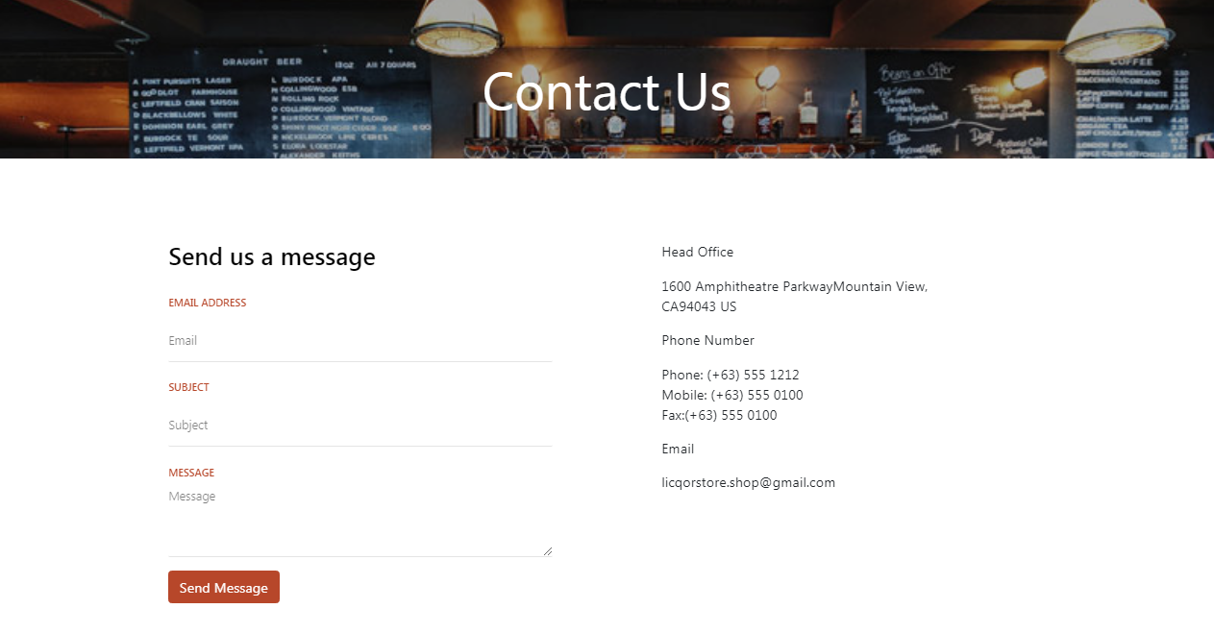

## Korpa

Stranica za ispisivanje odabranih itema sa sajta.Pristup strani je moguc ikona ’cart’ u navigacionom meniju. Nakon odabira itema se im se prikazuje lista odabranih.

Korisnik moze da obrise listu i da nastavi kopovinu.

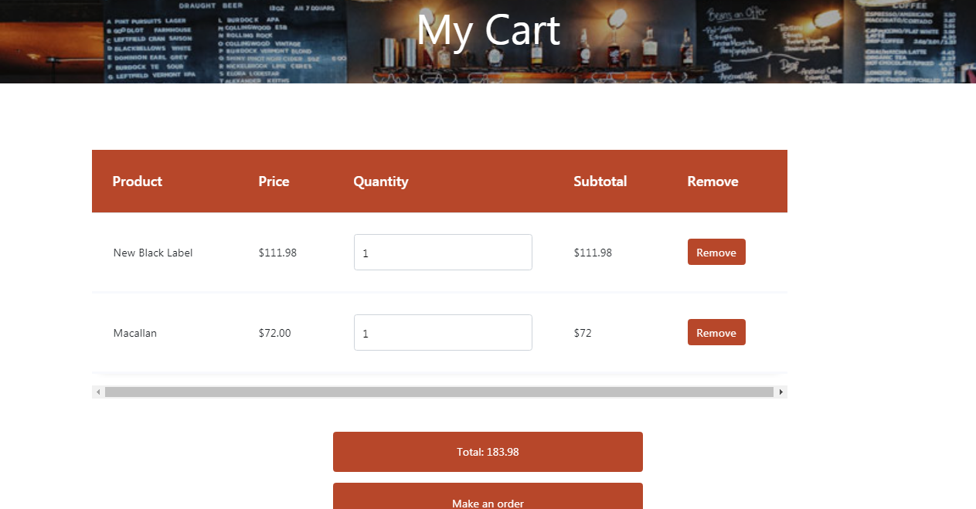

## Login

Stranica za logovanje korisnika/admina obezbedjena izrazima gde se posle uspesnog ili neuspesnog logovanja prikazuje poruka o stanju.

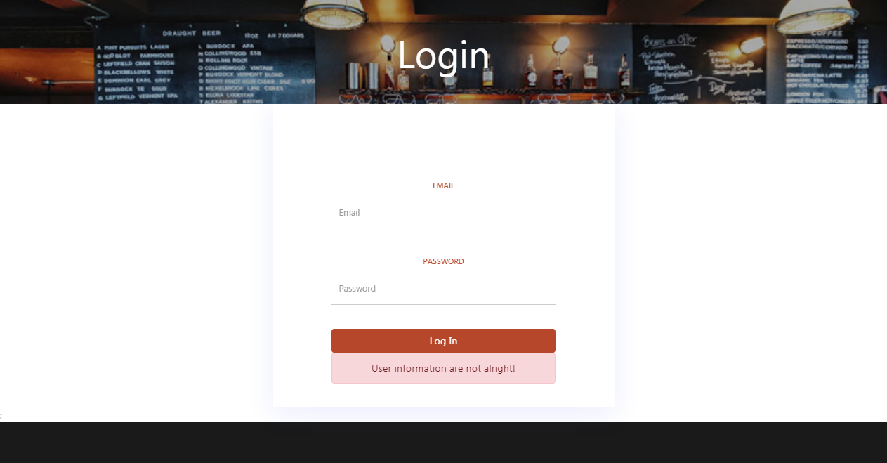

## Register

Stranica za registraciju novih korisnika obezbedjena regex izrazima za uspesnije upisivanje korisnika.Prilikom registracije korisnik dobija potvrdu dali je nalog kreiran.

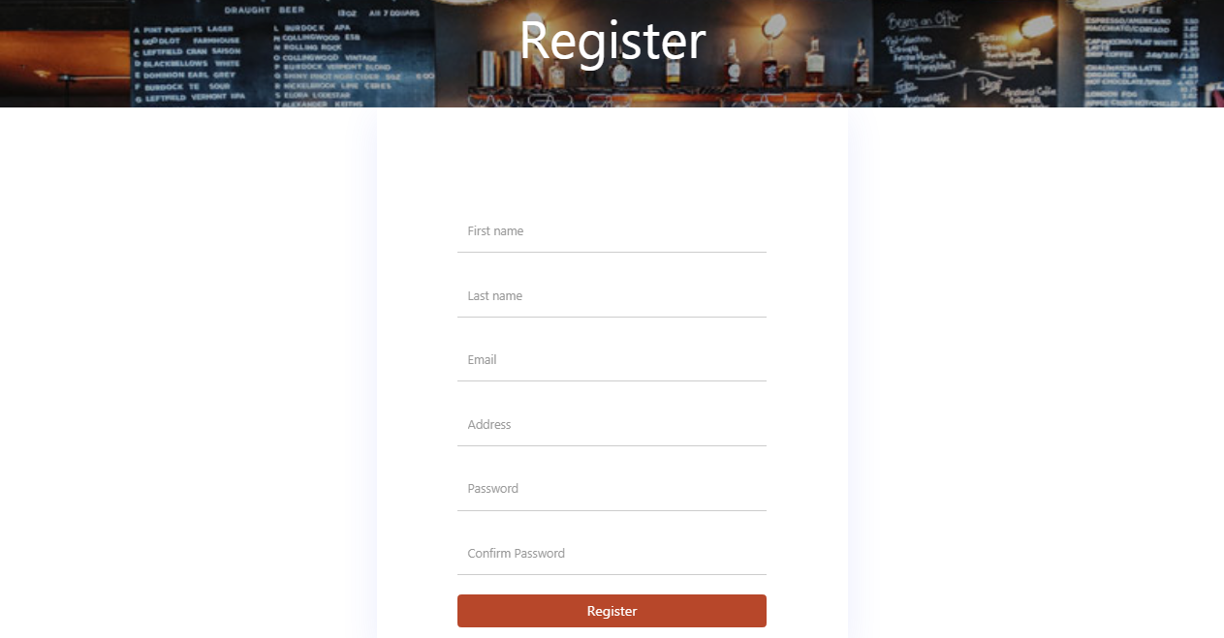

## Single-page

Ispisivanje izbranog proizvoda sa opsirnijim podacima iz sesije i klikom na ’lupa’ ikonu proizvoda.

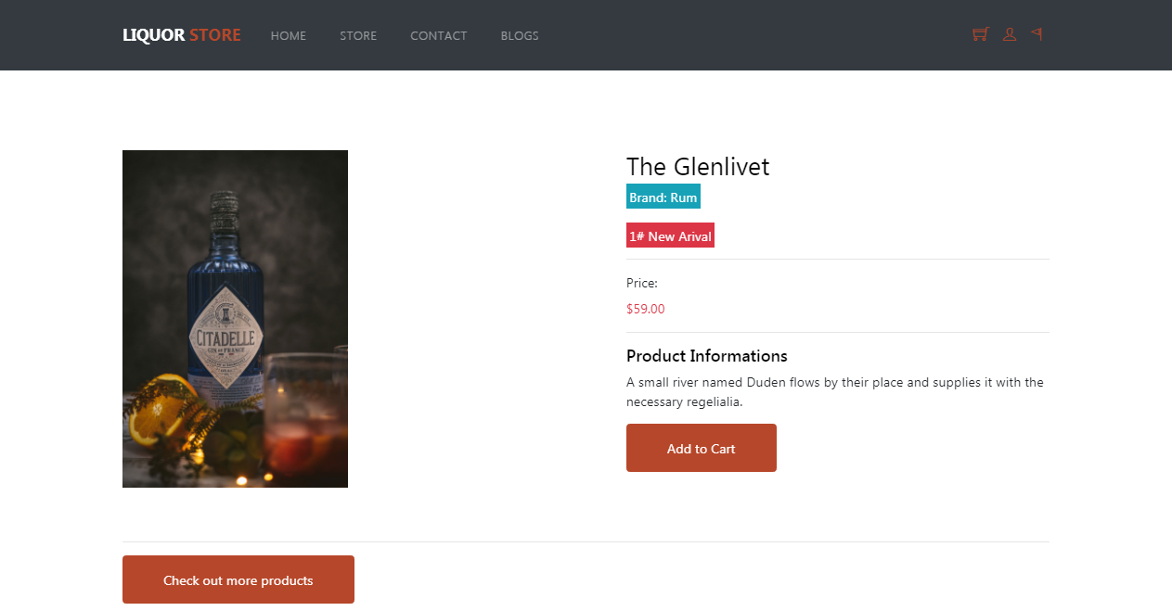

## Admin Panel

Pristup ovoj strani samo preko ’Admin panel’ linka koje se prikazujeu navigaciji.

Klikom na ’Delete’link sa desne strane admin moze da obrise izabrani proizvod sa sajta.

Klikom na ’Update’link sa desne strane odlazi do update strane za dalju obradu.

Home link odlazi do pocetne strane sajta, Logout link izloguje admina sa panela.

Linkovi sa leve strane prikazuju dodatne informacije o sajtu.

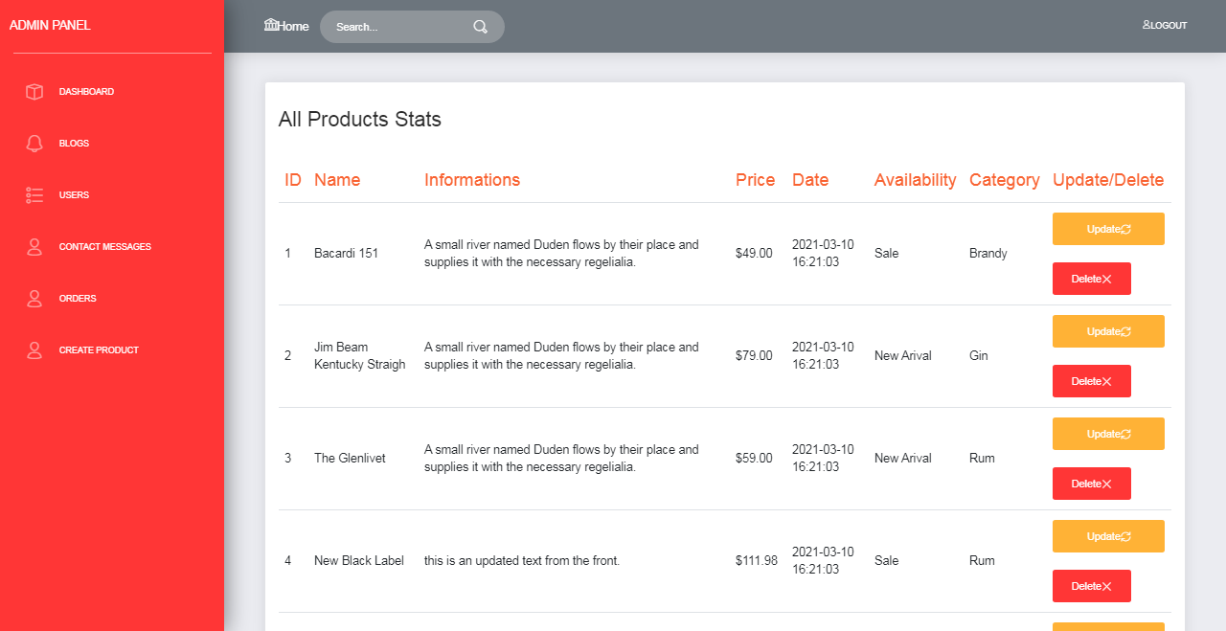

## Blogs link

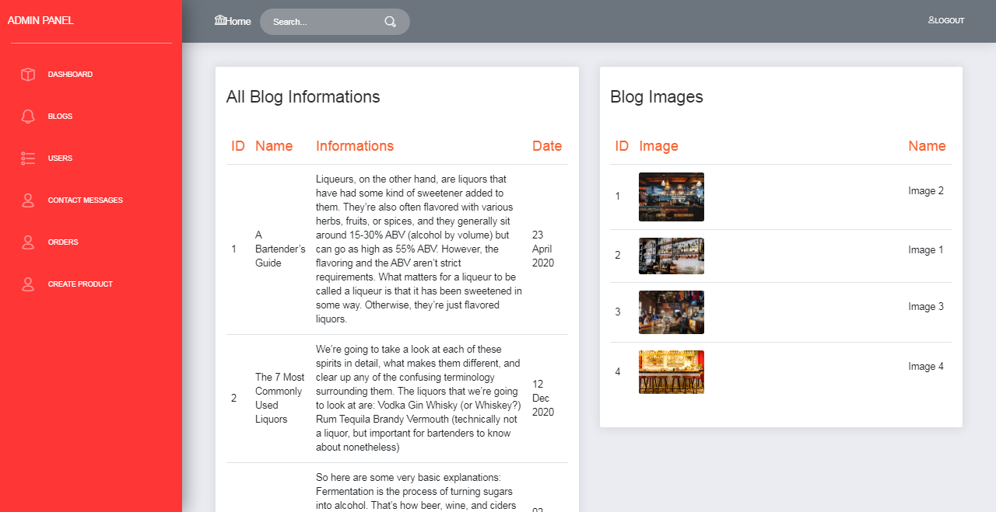

## Users link

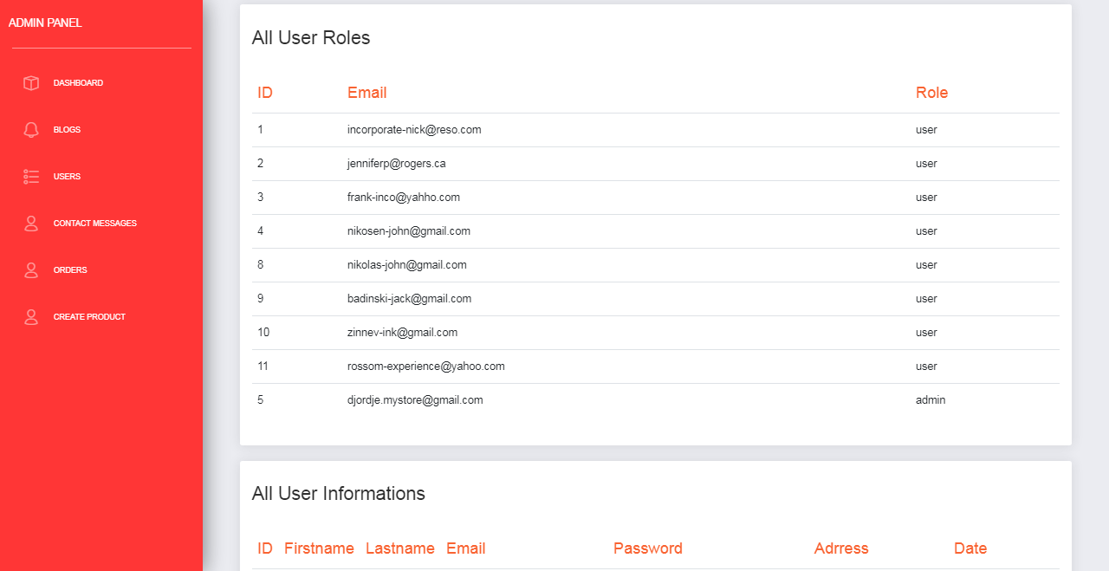

## Contact Messages link

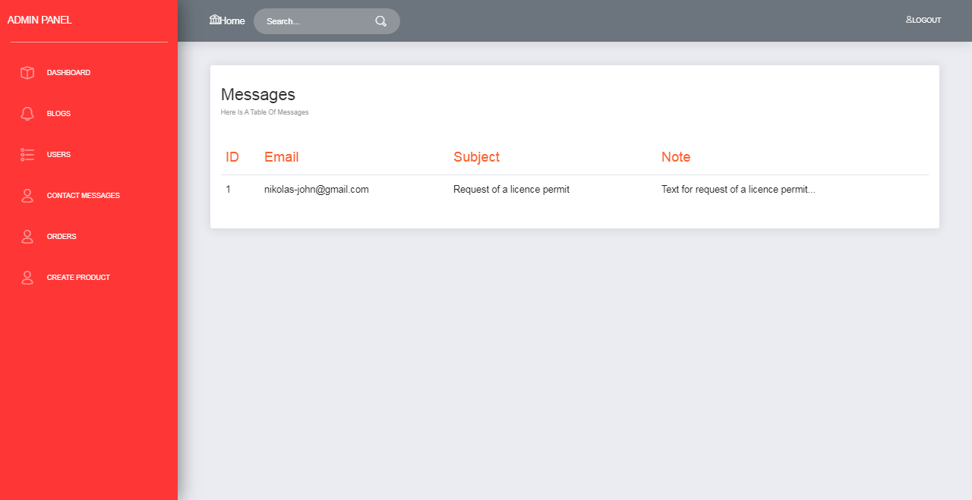

## Orders link

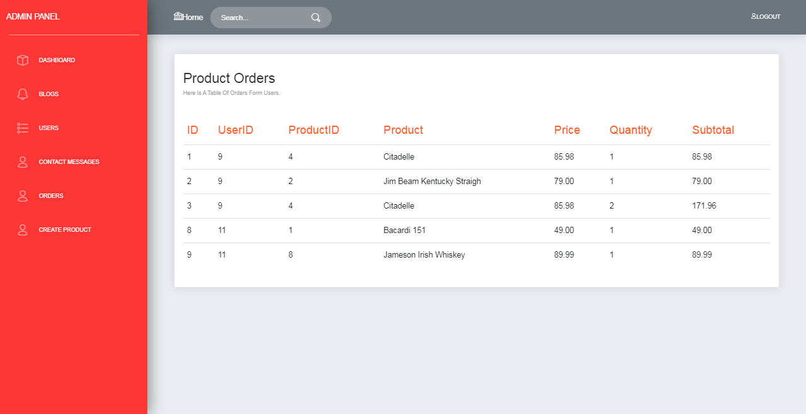

## Create Product link

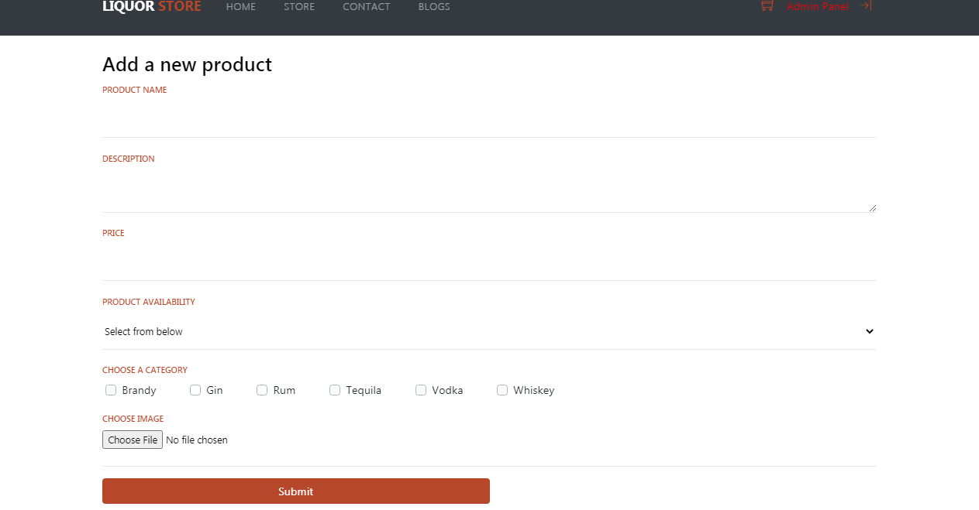

## Update link

Link se nalazi na dashboard ili pocetnoj strani admin panela pored svakog proizvoda.

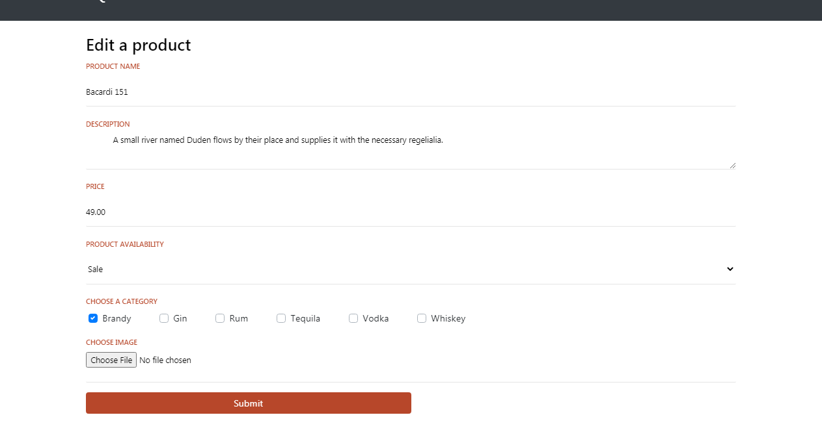

## Author

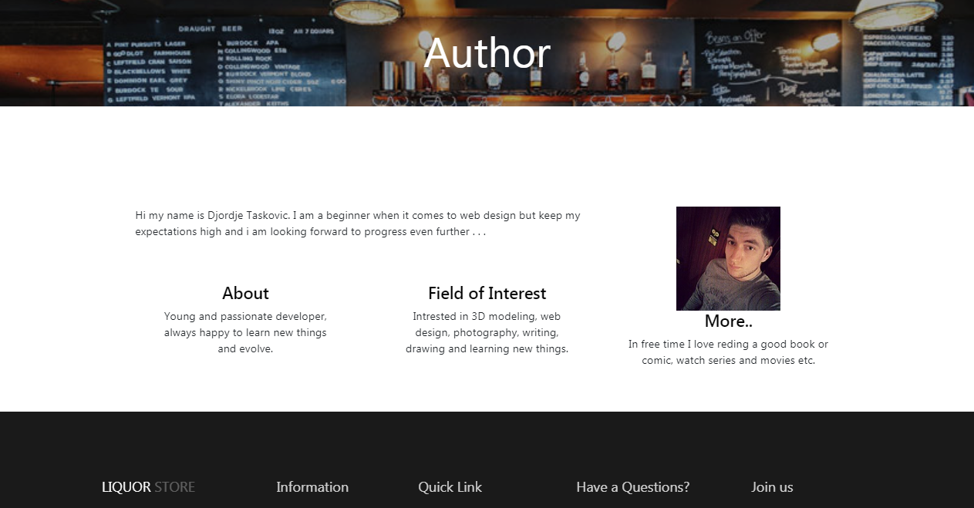

## Struktura projekta

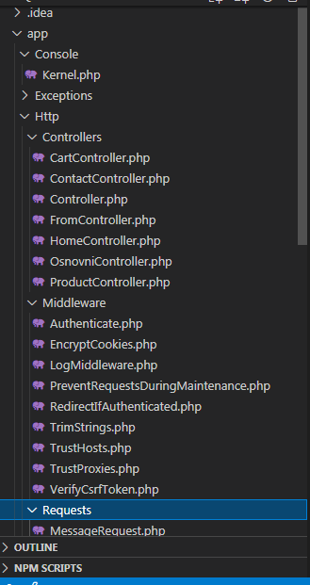

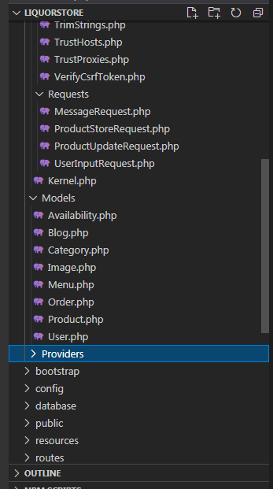

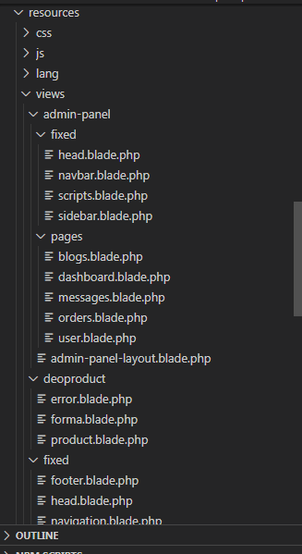

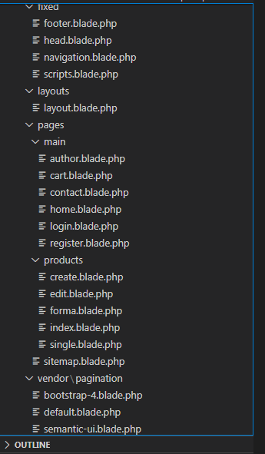

# Kodovi Sajta

## Php

### Rutes/web.php

<?php

use App\Http\Controllers\ContactController;

use App\Http\Controllers\HomeController;

use App\Http\Controllers\ProductController;

use App\Http\Controllers\CartController;

use App\Http\Controllers\FromController;

use Illuminate\Support\Facades\Route;

Route::middleware(['loggedIn'])->group(function () {

    Route::get('/admin', [HomeController::class, 'dashboard'])->name('admin');

    Route::get('/blogs', [HomeController::class, 'blogs'])->name('blogs');

    Route::get('/users', [HomeController::class, 'users'])->name('users');

    Route::get('/orders', [HomeController::class, 'orders'])->name('orders');

    Route::get('/messages', [HomeController::class, 'messages'])->name('messages');

    Route::get('/products/create', [ProductController::class, 'create'])->name('products.create');

    Route::post('/products', [ProductController::class, 'store'])->name('products.store');

    Route::get('/products/{product}/edit', [ProductController::class, 'edit'])->name('products.edit');

    Route::put('/products/{product}', [ProductController::class, 'update'])->name('products.update');

    Route::delete('/products/{product}', [ProductController::class, 'destroy'])->name('products.destroy');

});

Route::get('/', [HomeController::class, 'index']);

Route::get('/home', [HomeController::class, 'index'])->name('home');

Route::get('/home#blogs', [HomeController::class, 'index'])->name('home#blogs');

Route::get('/author', [HomeController::class, 'author'])->name('author');

Route::get('sitemap.xml',[HomeController::class,'sitemap'])->name('sitemap');

Route::get('/doc', function() {

return response()->file(public_path() . '/doc.pdf');

})->name('doc');

Route::get('/contacthome', [ContactController::class, 'index'])->name('contacthome');

Route::post('/contact', [ContactController::class, 'contact'])->name('contact');

Route::get('/cart', [CartController::class, 'index'])->name('cart');

Route::get('/addtocart/{product}', [CartController::class, 'addtocart'])->name('addtocart');

Route::get('/delfromcart/{id}', [CartController::class, 'delfromcart'])->name('delfromcart');

Route::get('/makeorder', [CartController::class, 'makeorder'])->name('makeorder');

Route::get('/logout', [FromController::class, 'logout'])->name('logout');

Route::get('/loginhome', [FromController::class, 'loginhome'])->name('loginhome');

Route::post('/login', [FromController::class, 'login'])->name('login');

Route::get('/error', [FromController::class,'error'])->name('error');

Route::get('/registerhome', [FromController::class, 'registerhome'])->name('registerhome');

Route::post('/register', [FromController::class, 'register'])->name('register');

Route::get('/store', [ProductController::class, 'index'])->name('store');

Route::get('/store/{product}', [ProductController::class, 'show'])->name('show');//

### CartController

<?php

namespace App\Http\Controllers;

use App\Models\Product;

use Exception;

use Illuminate\Http\Request;

use Illuminate\Support\Facades\DB;

class CartController extends OsnovniController

{

    public function index(){

        return view('pages.main.cart', $this->data);

    }

    public function addtocart(Product $product , Request $request){

    if($request->session()->has("user")){

        $cart = session()->get('cart');

        //if the cart is empty

        if (!$cart) {

           $cart = [

            $product->id =>[

                'id' =>$product->id,

                'name' =>$product->product_name,

                'price' =>$product->price,

                'quantity' => 1

                ]

           ];

           session()->put('cart',$cart);

           return redirect()->back()->with('cart_error','Your item has been added to cart.');

        }

        //if product exists in cart and quantity++

        if (isset($cart[$product->id])) {

            $cart[$product->id]['quantity']++;

           session()->put('cart',$cart);

           return redirect()->back()->with('cart_error','Your item has been added to cart.');

        }

        $cart[$product->id] = [

            'id' =>$product->id,

            'name' =>$product->product_name,

            'price' =>$product->price,

            'quantity' => 1

       ];

       session()->put('cart' , $cart);

       return redirect()->back()->with('cart_error','Your item has been added to cart.');

    }

    return redirect()->route("loginhome")->with('cart_error', 'You need to login first to add items to cart!');

    }

    public function delfromcart(Request $request){

       // dd($request->id);

        $cart = session()->get('cart');

        if (isset($cart[$request->id])) {

            unset($cart[$request->id]);

            session()->put('cart',$cart);

        }

        return redirect()->route("cart")->with('cart_error', 'Product removed from cart.');

    }

    public function makeorder(){

        $cart = session()->get('cart');

        $user = session()->get('user');

     //   dd($cart);

        if($user){

            DB::beginTransaction();

            try

            {

                       foreach($cart as $innercart){

                           $subtotal = $innercart['price'] * $innercart['quantity'];

                        DB::table('orders')->insert([

                            "product_id" => $innercart['id'],

                            "user_id" => $user->id_user,

                             "name" => $innercart['name'],

                             "price" =>$innercart['price'],

                             "quantity" => $innercart['quantity'],

                             "subtotal" => $subtotal

                             ]);

                       }

                DB::commit();

                return redirect()->route('cart')->with('success', 'Order added successfully!');

            }

            catch(Exception $e)

            {

                DB::rollBack();

                dd($e->getMessage());

                return redirect()->route('error')->with('errorMessage', 'An error occurred!');

            }

        }

    }

}

### ContactController

<?php

namespace App\Http\Controllers;

use Illuminate\Http\Request;

use App\Http\Requests\MessageRequest;

use Illuminate\Support\Facades\DB;

class ContactController extends OsnovniController

{

    public function index(){

        return view('pages.main.contact',$this->data);

    }

    public function contact(MessageRequest $request){

        DB::beginTransaction();

        try {

            DB::table('contacts')->insert([

                'email'=>$request->email,

                'subject'=>$request->subject,

                'message'=>$request->message

            ]);

            DB::commit();

            return redirect()->route("contacthome")->with('message','Your message has been sent.');

        } catch (\Throwable $th) {

            DB::rollBack();

            dd($th->getMessage());

            return redirect()->route('error')->with('errorMessage', 'An error occurred!');

        }

        return view('pages.main.contact',$this->data);

    }

}

### FormController

<?php

namespace App\Http\Controllers;

use App\Http\Requests\UserInputRequest;

use Exception;

use Illuminate\Http\Request;

use Illuminate\Support\Facades\DB;

use Auth;

class FromController extends OsnovniController

{

    public function loginhome(){

         return view('pages.main.login', $this->data);

    }

    public function registerhome(){

        return view('pages.main.register', $this->data);

    }

    public function logout(Request $request) {

        $request->session()->remove("user");

        $request->session()->remove("cart");

        return redirect()->route("home");

    }

    public function login(Request $request){

        $email = $request->input('email');

        $password = $request->input('password');

        $pass = md5($password);

        try {

            $user = DB::table("users")

                ->join('user_role','users.id','=','user_role.id_user')

                ->join('roles','user_role.id_role','=','roles.id')

                ->where("email", "=", $email)

                ->where("password", "=", $pass)

                ->first();

                if($user){

                    if($user->role_name =='admin'){

                        $user->adminrole = true;

                    }else{

                        $user->adminrole = false;

                    }

                     $request->session()->put("user", $user);

                    return redirect()->route("store");

                }if($user = "null"){

                            return redirect()->route("loginhome")

                            ->with('errorMessage', 'User information are not alright!');

                }

            } catch (\Exception $e) {

                    dd($e->getMessage());

                    return redirect()->route("error")->with('errorMessage', 'An error occurred!');

                }

    }

    public function register(UserInputRequest $request){

        $pass = md5($request->password);

        DB::beginTransaction();

        try{

            $userid = DB::table('users')->insertGetId([

                "firstname" => $request->fname,

                "lastname" => $request->lname,

                "email" => $request->email,

                "address" => $request->address,

                "password" => $pass

            ]);

            DB::table('user_role')->insert([

                "id_user"=> $userid,

                "id_role"=> 1,

            ]);

            DB::commit();

                //login_after_register

               $logedin_user = DB::table("users")

                ->join('user_role','users.id','=','user_role.id_user')

                ->join('roles','user_role.id_role','=','roles.id')

                ->where("users.id", "=", $userid)

                ->first();

                if($logedin_user->role_name =='admin'){

                    $logedin_user->adminrole = true;

                }else{

                    $logedin_user->adminrole = false;

                }

               if($logedin_user){

                $request->session()->put("user", $logedin_user);

                return redirect()->route("store");

            }if($logedin_user ="null"){

                return redirect()->route("loginhome")

                ->with('errorMessage', 'User information are not alright!');

             }

        } catch (Exception $th) {

            DB::rollBack();

            dd($th->getMessage());

            return redirect()->route('error')->with('errorMessage', 'An error occurred!');

        }

    }

    public function error(){

        return view('deoproduct.error',$this->data);

    }

}

### HomeController

<?php

namespace App\Http\Controllers;

use App\Models\Product;

use App\Models\Blog;

use App\Models\Order;

use Illuminate\Support\Facades\DB;

use Illuminate\Http\Request;

class HomeController extends OsnovniController

{

    private $ModelProduct;

    public function __construct()

    {

        parent::__construct();

        $this->ModelProduct = new Product();

    }

    public function index(Request $request){

        $this->data['products'] = $this->ModelProduct->getitems($request)->paginate(4);

        $this->data["blogs"] = Blog::with('images')->get();

        return view('pages.main.home', $this->data);

    }

    public function author(){

        return view('pages.main.author',$this->data);

    }

    public function dashboard(){

        $this->data["products"] = Product::with('images','availabilities','categories')->get();

        return view('admin-panel.pages.dashboard', $this->data);

    }

    public function blogs(){

        $this->data["blogs"] = Blog::with('images')->get();

        return view('admin-panel.pages.blogs',$this->data);

    }

    public function users(){

        $this->data["users"] = DB::table('users')

        ->join('user_role','users.id','=','user_role.id_user')

        ->join('roles','user_role.id_role','=','roles.id')

        ->select('users.*','roles.role_name')

        ->get();

        return view('admin-panel.pages.user',$this->data);

    }

    public function messages(){

        $this->data['messages'] = DB::table('contacts')->get();

        return view('admin-panel.pages.messages',$this->data);

    }

    public function orders(){

        $this->data['orders'] = Order::all();

        return view('admin-panel.pages.orders',$this->data);

    }

    public function sitemap(){

        return response()->view('pages.sitemap')->header('Content-Type','text/xml');

    }

}

### OsnovniController

<?php

namespace App\Http\Controllers;

use App\Models\Menu;

use App\Models\Product;

use Illuminate\Http\Request;

class OsnovniController extends Controller

{

    public $data;

    public function __construct()

    {

        $this->data["menu"] = Menu::getMenu();

        $this->data['sidebar'] =Product::sidebar();

    }

}

### ProductController

<?php

namespace App\Http\Controllers;

use App\Http\Requests\ProductStoreRequest;

use App\Http\Requests\ProductUpdateRequest;

use App\Models\Availability;

use App\Models\Product;

use App\Models\Category;

use App\Models\Image;

use Exception;

use Illuminate\Database\Eloquent\Model;

use Illuminate\Http\Request;

use Illuminate\Support\Facades\DB;

class ProductController extends OsnovniController

{

    private $ModelProduct;

    private $slika;

    private $url;

    public function __construct()

    {

        parent::__construct();

        $this->ModelProduct = new Product();

    }

    public function index(Request $request){

        $this->data['sortname'] = $this->ModelProduct::sortname();

        $this->data['items'] = $this->ModelProduct->getitems($request)->paginate(6);

        $this->data['checkedcategories'] = $request->get("catids");

        $this->data["categories"] = Category::all();

        $this->data["avaliabilities"] = Availability::all();

        return view('pages.products.index', $this->data);

    }

    public function show(Product $product){

        $this->data["product"] = $product;

        return view('pages.products.single', $this->data);

    }

    public function create(){

        $this->data["categories"] = Category::all();

        $this->data["availability"] = Availability::all();

        return view ('pages.products.create', $this->data);

    }

    public function store(ProductStoreRequest $request){

        DB::beginTransaction();

        try

        {

            $image = Product::uploadImage($request->image);

               $imageID = DB::table('images')->insertGetId([

                     'url'=> $image,

                    'alt'=> $request->image_info

                ]);

                $productID = DB::table('products')->insertGetId(

                    $request->only('product_name','info', 'price'));

                 foreach($request->category_id as $category){

                    DB::table('category_product')->insert([

                        "category_id" => $category,

                         "product_id" => $productID]);

                }

                 DB::table('availability_product')->insert([

                    "product_id" => $productID,

                    "availability_id" => $request->state

                 ]);

                 DB::table('image_product')->insert([

                    "image_id" => $imageID,

                 "product_id" => $productID

                  ]);

            DB::commit();

            return redirect()->route('products.create')->with('success', 'Product added successfully!');

        }

        catch(Exception $e)

        {

            DB::rollBack();

            dd($e->getMessage());

            return redirect()->route('error')->with('errorMessage', 'An error occurred!');

        }

    }

    public function edit(Product $product){

        $this->data["categories"] = Category::all();

        $this->data["product"] = $product;

        $this->data["availability"] = Availability::all();

        return view('pages.products.edit', $this->data);

    }

    public function update(ProductUpdateRequest $request, Product $product){

      //  dd($request->all());

        DB::beginTransaction();

        try

        {

            Product::where('id','=',$request->ID)

                ->update([

                'product_name'=>$request->product_name,

                'info'=>$request->info,

                'price'=>$request->price

                ]);

            $product->categories()->sync($request->category_id);

            $product->availabilities()->sync($request->state_id);

            if($request->has('image')){

                 $oldimageurl = Product::oldImage($product);

                Product::deleteImage($oldimageurl);

                $newImage = Product::uploadImage($request->image);

                $product->images()->update(['url' => $newImage]);

            }

            $product->save();

             DB::commit();

             return redirect()->route('products.edit', $product->id)->with('success', 'Product edited successfully!');

         }

         catch(Exception $e)

         {

             DB::rollBack();

             dd($e->getMessage());

             return redirect()->route('products.edit', $product->id)->with('errorMessage', 'An error occurred!');

         }

    }

    public function destroy(Product $product){

            $product->categories()->detach();

            $product->availabilities()->detach();

            $product->images()->detach();

            $product->delete();

            return redirect()->route('admin');

    }

}

### LogMiddleware

<?php

namespace App\Http\Middleware;

use Closure;

use Illuminate\Http\Request;

class LogMiddleware

{

    /**

     * Handle an incoming request.

     *

     * @param  \Illuminate\Http\Request  $request

     * @param  \Closure  $next

     * @return mixed

     */

    public function handle(Request $request, Closure $next)

    {

        if($request->session()->has("user") && $request->session()->get('user')->adminrole){

            return $next($request);

        }

        return redirect()->route("home")->with('loginmessage', 'You need to login first to access the page.');

    }

}

### MessageRequest

<?php

namespace App\Http\Requests;

use Illuminate\Foundation\Http\FormRequest;

class MessageRequest extends FormRequest

{

    /**

     * Determine if the user is authorized to make this request.

     *

     * @return bool

     */

    public function authorize()

    {

        return true;

    }

    /**

     * Get the validation rules that apply to the request.

     *

     * @return array

     */

    public function rules()

    {

        return [

            'email' => 'required|email',

            'subject' => 'required|max:50|min:2',

            'message' => 'required|max:255|min:2'

        ];

    }

    public function messages(){

        return [

            'required' => 'The :attribute field is required.',

            'subject.max' => 'Subject must not be longer than :max characters.',

            'subject.min' => 'Subject must be longer than :min characters.',

            'message.max' => 'Message must not be longer than :max characters.',

            'message.min' => 'Message must be longer than :min characters.'

        ];

    }

}

### ProductStoreRequest

<?php

namespace App\Http\Requests;

use Illuminate\Foundation\Http\FormRequest;

class ProductStoreRequest extends FormRequest

{

    /**

     * Determine if the user is authorized to make this request.

     *

     * @return bool

     */

    public function authorize()

    {

        return true;

    }

    /**

     * Get the validation rules that apply to the request.

     *

     * @return array

     */

    public function rules()

    {

        return [

            'product_name' => 'required|unique:products,product_name|max:30|min:3',

            'price' => 'required|numeric',

            'info' => 'required|max:500',

            'state_id' => 'required|exists:availabilities,id',

            'image' => 'required|image|max:2000',

            'category_id' => 'required|exists:categories,id'

        ];

    }

    public function messages(){

        return [

            'required' => 'The :attribute field is required.',

            'name.max' => 'Name must not be longer than :max characters.',

            'numeric' => 'The :attribute field must have a numeric value.',

            'info.max' => 'Description must not be longer than :max characters.',

            'image.image' => 'Uploaded file must be an image.',

            'image.max' => 'Uploaded file must not be larger than :max kilobytes.',

            'category_id.exists' => 'Selected category does not exist in the database.'

        ];

    }

}

### ProductUpdateRequest

<?php

namespace App\Http\Requests;

use Illuminate\Foundation\Http\FormRequest;

class ProductUpdateRequest extends FormRequest

{

    /**

     * Determine if the user is authorized to make this request.

     *

     * @return bool

     */

    public function authorize()

    {

        return true;

    }

    /**

     * Get the validation rules that apply to the request.

     *

     * @return array

     */

    public function rules()

    {

        return [

            'ID' => 'max:1|min:1|exists:products,id',

            'product_name' => 'required|max:30|min:3',

            'price' => 'required|numeric',

            'info' => 'required|max:500',

            'state_id' => 'required|exists:availabilities,id',

            'image' => 'image|max:2000',

            'category_id' => 'required|exists:categories,id'

        ];

    }

    public function messages(){

        return [

            'required' => 'The :attribute field is required.',

            'name.max' => 'Name must not be longer than :max characters.',

            'numeric' => 'The :attribute field must have a numeric value.',

            'info.max' => 'Description must not be longer than :max characters.',

            'image.image' => 'Uploaded file must be an image.',

            'image.max' => 'Uploaded file must not be larger than :max kilobytes.',

            'category_id.exists' => 'Selected category does not exist in the database.'

        ];

    }

}

### UserInputRequest

<?php

namespace App\Http\Requests;

use Illuminate\Foundation\Http\FormRequest;

class UserInputRequest extends FormRequest

{

    /**

     * Determine if the user is authorized to make this request.

     *

     * @return bool

     */

    public function authorize()

    {

        return true;

    }

    /**

     * Get the validation rules that apply to the request.

     *

     * @return array

     */

    public function rules()

    {

        return [

            'fname' => 'required|max:30|min:2',

            'lname' => 'required|max:30|min:2',

            'email' => 'required|email|unique:users',

            'address' => 'required|min:5',

            'password' => 'required|min:8',

            'confirmpassword' => 'required|same:password'

        ];

    }

    public function messages(){

        return [

             'required' => 'The :attribute field is required.',

             'firstname.min' => 'Firstame must be longer than :min characters.',

             'lastname.min' => 'Lastame must be longer than :min characters.',

             'address.min' => 'Address must be longer than :min characters.',

             'password.min' => 'Password must be longer than :min characters.',

             'confirmpassword.same' => 'Repeted password must be same.',

        ];

    }

}

### Availability

<?php

namespace App\Models;

use Illuminate\Database\Eloquent\Factories\HasFactory;

use Illuminate\Database\Eloquent\Model;

class Availability extends Model

{

    use HasFactory;

    public function products(){

        return $this->belongsToMany(Product::class);

    }

}

### Blog

<?php

namespace App\Models;

use Illuminate\Database\Eloquent\Factories\HasFactory;

use Illuminate\Database\Eloquent\Model;

class Blog extends Model

{

    use HasFactory;

    public function images(){

        return $this->belongsToMany(Image::class);

    }

}

### Category

<?php

namespace App\Models;

use Illuminate\Database\Eloquent\Factories\HasFactory;

use Illuminate\Database\Eloquent\Model;

class Category extends Model

{

    use HasFactory;

    public function products(){

        return $this->belongsToMany(Product::class);

    }

}

### Image

<?php

namespace App\Models;

use Illuminate\Database\Eloquent\Factories\HasFactory;

use Illuminate\Database\Eloquent\Model;

class Image extends Model

{

    use HasFactory;

    public $timestamps = false;

    public function products(){

        return $this->belongsToMany(Product::class);

    }

}

### Menu

<?php

namespace App\Models;

use Illuminate\Database\Eloquent\Factories\HasFactory;

use Illuminate\Database\Eloquent\Model;

class Menu extends Model

{

    use HasFactory;

    public static function getMenu(){

        return Menu::all();

    }

}

### Order

<?php

namespace App\Models;

use Illuminate\Database\Eloquent\Factories\HasFactory;

use Illuminate\Database\Eloquent\Model;

use Illuminate\Http\Request;

class Order extends Model

{

    use HasFactory;

    public function products(){

        return $this->belongsToMany(Product::class);

    }

    public static function cart($product){

        $niz = [];

        array_push($niz ,$product);

        return;

    }

}

### Product

<?php

namespace App\Models;

use Illuminate\Database\Eloquent\Factories\HasFactory;

use Illuminate\Database\Eloquent\Model;

use Illuminate\Http\Request;

use Illuminate\Support\Facades\DB;

use Illuminate\Support\Facades\Storage;

class Product extends Model

{

    use HasFactory;

    protected $fillable = ['product_name'];

    public $timestamps = false;

    public function categories(){

        return $this->belongsToMany(Category::class);

    }

    public function images(){

        return $this->belongsToMany(Image::class);

    }

    public function availabilities(){

        return $this->belongsToMany(Availability::class);

    }

    public function getitems(Request $request){

        $upit = DB::table('products');

        $upit = $upit->join('category_product','products.id','=','category_product.product_id');

        $upit = $upit->join('categories','category_product.category_id','=','categories.id');

        $upit = $upit->join('image_product','image_product.product_id','=','products.id');

        $upit = $upit->join('images','image_product.image_id','=','images.id');

        $upit = $upit->join('availability_product','availability_product.product_id','=','products.id');

        $upit = $upit->join('availabilities','availability_product.availability_id','=','availabilities.id');

        if($request->has('catids')){

            $upit = $upit->whereIn('categories.id',$request->get('catids'));

        }

        if($request->has('pretraga')){

         $upit = $upit->where("products.product_name","like","%".$request->get('pretraga')."%");

        }

        //sort po nekom nazivu

        if($request->has("sortBy")) {

            $upit = $upit->orderBy($request->get("sortBy"));

        }

        if($request->has("cenasort")){

        $request->get("cenasort")=="asc" ? $upit = $upit->orderBy("products.price")

        :$upit = $upit->orderByDESC("products.price");

        //order po asc i desc

        }

        $upit = $upit->select('products.*','categories.id as catID','categories.category_name','images.url',

            'availabilities.state','availabilities.id as stateID');

        return $upit;

    }

    public static function sortname(){

        $niz = [['id'=>'asc','name'=>'Low to High'],['id'=>'desc','name'=>'High to Low']];

        return $niz;

    }

    public static function sidebar(){

        $niz = [

            ['id'=>'admin','name'=>'Dashboard','icon'=>'design_app'],

            ['id'=>'blogs','name'=>'Blogs','icon'=>'ui-1_bell-53'],

            ['id'=>'users','name'=>'Users','icon'=>'design_bullet-list-67'],

            ['id'=>'messages','name'=>'Contact Messages','icon'=>'users_single-02'],

            ['id'=>'orders','name'=>'Orders','icon'=>'users_single-02'],

            ['id'=>'products.create','name'=>'Create Product','icon'=>'users_single-02']

        ];

        return $niz;

     }

    public static function uploadImage($image){

        $path = Storage::disk('public')->putFile('assets/img/products', $image);

        $exploded = explode('/', $path);

        return $exploded[count($exploded) - 1];

    }

    public static function deleteImage($image){

        Storage::disk('public')->delete('assets/img/products' . $image);

    }

    public static function oldImage($product){

        $ImageID = DB::table('image_product')

            ->select('image_id')

            ->where('product_id', $product->id)->get();

        foreach ($ImageID as $id){

            $slika = $id->image_id;

        }

        $oldImage = DB::table('images')

            ->select('url')

            ->where('id', $slika)->get();

        foreach ($oldImage as $ol){

            $url = $ol->url;

        }

        return $url;

    }

}

## Blade fajlovi

### Admin-panel/fixed

#### Head

<head>

    <title>@yield('title')</title>

    <meta charset="utf-8" />

    <meta name="viewport" content="width=device-width, initial-scale=1, shrink-to-fit=no" />

    <meta name="description" content="@yield('description')">

    <meta name="author" content="@yield('keywords')">

  <link href="https://fonts.googleapis.com/css?family=Montserrat:400,700,200" rel="stylesheet" />

  <link rel="stylesheet" href="https://use.fontawesome.com/releases/v5.7.1/css/all.css"

  integrity="sha384-fnmOCqbTlWIlj8LyTjo7mOUStjsKC4pOpQbqyi7RrhN7udi9RwhKkMHpvLbHG9Sr" crossorigin="anonymous">

  <link rel="icon" href="{{ asset('assets/img/other/icon.png') }}" type="image/png">

    <link rel="stylesheet" href="{{ asset('assets/vendor/bootstrap/css/bootstrap.min.css') }}"/>

    <link rel="stylesheet" href="{{ asset('assets/demo/demo.css') }}"/>

    <link rel="stylesheet" href="{{ asset('assets/css/now-ui-dashboard.css') }}"/>

</head>

#### Navbar

<nav class="navbar navbar-expand-lg bg-secondary navbar-absolute">

        <div class="container-fluid">

          <div class="navbar-wrapper">

            <div class="navbar-toggle">

              <button type="button" class="navbar-toggler">

                <span class="navbar-toggler-bar bar1"></span>

                <span class="navbar-toggler-bar bar2"></span>

                <span class="navbar-toggler-bar bar3"></span>

              </button>

            </div>

            <a class="nav-link" href="{{ route('home')}}">

            <span class="now-ui-icons business_bank" aria-hidden="true"></span><p>Home</p>

            </a>

          </div>

          <button class="navbar-toggler" type="button" data-toggle="collapse" data-target="#navigation"

          aria-controls="navigation-index" aria-expanded="false" aria-label="Toggle navigation">

            <span class="navbar-toggler-bar navbar-kebab"></span>

            <span class="navbar-toggler-bar navbar-kebab"></span>

            <span class="navbar-toggler-bar navbar-kebab"></span>

          </button>

          <div class="collapse navbar-collapse justify-content-between" id="navigation">

            <form>

              <div class="input-group no-border">

                <input type="text" value="" class="form-control" placeholder="Search...">

                <div class="input-group-append">

                  <div class="input-group-text">

                    <i class="now-ui-icons ui-1_zoom-bold"></i>

                  </div>

                </div>

              </div>

            </form>

            <ul class="navbar-nav">

              <li class="nav-item">

                <a class="nav-link" href="{{ route('logout')}}">

                    <span class="now-ui-icons users_single-02" aria-hidden="true"></span><p>Logout</p></a>

              </li>

            </ul>

          </div>

        </div>

      </nav>

#### Scripts

<script src="{{ asset('assets/vendor/jquery/jquery.js') }}"></script>

  <script src="{{ asset('assets/js/plugins/popper.min.js') }}"></script>

  <script src="{{ asset('assets/js/plugins/perfect-scrollbar.jquery.min.js') }}"></script>

  {{-- <script src="{{ asset('assets/js/plugins/chartjs.min.js') }}"></script> --}}

  <script src="{{ asset('assets/js/plugins/bootstrap-notify.js') }}"></script>

<script src="{{ asset('assets/vendor/bootstrap/js/bootstrap.bundle.js') }}"></script>

<script src="{{ asset('assets/js/main.js') }}"></script>

<script src="{{ asset('assets/js/now-ui-dashboard.min.js') }}"></script>

<script src="{{ asset('assets/demo/demo.js') }}"></script>

  <script>

    $(document).ready(function() {

      // Javascript method's body can be found in assets/js/demos.js

      demo.initDashboardPageCharts();

    });

  </script>

@yield('javascript')

#### Sidebar

<div class="sidebar" data-color="red">

      <div class="logo">

        <a class="simple-text logo-normal">Admin Panel</a>

      </div>

      <div class="sidebar-wrapper" id="sidebar-wrapper">

        <ul class="nav">

            @foreach ($sidebar as $s)

            <li>

            <a href="{{ route($s['id'])}}">

                  <i class="now-ui-icons {{$s['icon']}}"></i>

                  <p>{{$s['name']}}</p>

                </a>

              </li>

            @endforeach

        </ul>

      </div>

    </div>

### Admin-panel/pages

#### Blogs

@extends('admin-panel.admin-panel-layout')

@section('title')Blogs @endsection

@section('description')Admin-dashboard @endsection

@section('keywords') panel,admin @endsection

@section('content')

<div class="content pt-5">

    <div class="row">

      <div class="col-md-6">

        <div class="card">

          <div class="card-header">

            <h4 class="card-title"> All Blog Informations</h4>

          </div>

          <div class="card-body">

            <div class="table-responsive">

              <table class="table">

                <thead class=" text-primary">

                  <th>ID</th>

                  <th>Name</th>

                  <th>Informations</th>

                  <th>Date </th>

                </thead>

                <tbody>

                    @foreach ($blogs as $p)

                    <tr>

                        <td>{{$p->id}}</td>

                        <td>{{$p->name}}</td>

                        <td>{{$p->info}}</td>

                        <td> {{$p->date}}</td>

                      </tr>

                    @endforeach

                </tbody>

              </table>

            </div>

          </div>

        </div>

      </div>

      <div class="col-md-6">

        <div class="card">

            <div class="card-header">

              <h4 class="card-title">Blog Images</h4>

            </div>

            <div class="card-body">

              <div class="table-responsive">

                <table class="table">

                  <thead class=" text-primary">

                    <th>ID</th>

                    <th>Image</th>

                    <th>Name</th>

                  </thead>

                  <tbody>

                      @foreach ($blogs as $p)

                      <tr>

                          <td>{{$p->id}}</td>

                          <td>

                              @foreach ($p->images as $i)

                                      <img class="w-25" src="{{ ('assets/img/blog/' . $i->url) }}" />

                              @endforeach

                          </td>

                          <td>

                            @foreach ($p->images as $i)

                                   <p>{{$i->alt}}</p>

                            @endforeach

                        </td>

                        </tr>

                      @endforeach

                  </tbody>

                </table>

              </div>

            </div>

          </div>

      </div>

    </div>

  </div>

@endsection

#### Dashboard

@extends('admin-panel.admin-panel-layout')

@section('title')Dashboard @endsection

@section('description')Admin-dashboard @endsection

@section('keywords') panel,admin @endsection

@section('content')

<div class="content pt-5">

    <div class="row">

      <div class="col-md-12">

        <div class="card">

          <div class="card-header">

            <h4 class="card-title"> All Products Stats</h4>

          </div>

          <div class="card-body">

            <div class="table-responsive">

              <table class="table">

                <thead class=" text-primary">

                  <th>ID</th>

                  <th>Name</th>

                  <th>Informations</th>

                  <th >Price</th>

                  <th>Date </th>

                  <th>Availability</th>

                  <th>Category</th>

                  <th>Update/Delete</th>

                </thead>

                <tbody>

                    @foreach ($products as $p)

                    <tr>

                        <td>{{$p->id}}</td>

                        <td>{{$p->product_name}}</td>

                        <td>{{$p->info}}</td>

                        <td>${{$p->price}}</td>

                        <td> {{$p->date}}</td>

                        <td>

                            @foreach ($p->availabilities as $i)

                                    {{$i->state}}

                            @endforeach

                        </td>

                        <td>

                            @foreach ($p->categories as $i)

                                    {{$i->category_name}}

                            @endforeach

                        </td>

                        <td>

                <a href="{{ route('products.edit',["product" => $p->id]) }}"

                class="d-flex align-items-center justify-content-center btn btn-warning">

                Update<span class="now-ui-icons arrows-1_refresh-69" aria-hidden="true"></span></a>

                 <br>

                <form method="POST" action="{{route('products.destroy',["product" => $p->id]) }}">

                @method('DELETE')

                @csrf

                <button onclick="return confirm('Are you sure you want to delete item?')"

                 class="d-flex align-items-center justify-content-center btn btn-danger"

                type="submit"> Delete <span class="now-ui-icons ui-1_simple-remove"

                     aria-hidden="true"></span></button>

                </form>

                        </td>

                      </tr>

                    @endforeach

                </tbody>

              </table>

            </div>

          </div>

        </div>

      </div>

      <div class="col-md-12">

        <div class="card">

            <div class="card-header">

              <h4 class="card-title">Products Images</h4>

            </div>

            <div class="card-body">

              <div class="table-responsive">

                <table class="table">

                  <thead class=" text-primary">

                    <th>ID</th>

                    <th>Image</th>

                    <th>Name</th>

                  </thead>

                  <tbody>

                      @foreach ($products as $p)

                      <tr>

                          <td>{{$p->id}}</td>

                          <td>

                              @foreach ($p->images as $i)

                                      <img class="w-25" src="{{ ('assets/img/products/' . $i->url) }}" />

                              @endforeach

                          </td>

                          <td>

                              @foreach ($p->images as $i)

                                      {{$i->url}}

                              @endforeach

                          </td>

                        </tr>

                      @endforeach

                  </tbody>

                </table>

              </div>

            </div>

          </div>

      </div>

    </div>

  </div>

@endsection

#### Messages

@extends('admin-panel.admin-panel-layout')

@section('title')Messages @endsection

@section('description')Admin-tables @endsection

@section('keywords') panel,admin @endsection

@section('content')

<div class="content pt-5">

    <div class="row">

      <div class="col-md-12">

        <div class="card">

          <div class="card-header">

            <h4 class="card-title"> Messages</h4>

            <p class="category"> Here is a table of messages</p>

          </div>

          <div class="card-body">

            <div class="table-responsive">

              <table class="table">

                <thead class=" text-primary">

                  <th>ID</th>

                  <th>Email

                  </th>

                  <th>Subject

                  </th>

                  <th>Note

                  </th>

                </thead>

                <tbody>

                    @foreach ($messages as $m )

                    <tr>

                      <td>{{$m->id}}</td>

                      <td> {{$m->email}}</td>

                      <td> {{$m->subject}}</td>

                      <td >{{$m->message}}</td>

                    </tr>

                    @endforeach

                </tbody>

              </table>

            </div>

          </div>

        </div>

      </div>

    </div>

  </div>

  @endsection

#### Orders

@extends('admin-panel.admin-panel-layout')

@section('title')Orders @endsection

@section('description')Admin-tables @endsection

@section('keywords') panel,admin @endsection

@section('content')

<div class="content pt-5">

    <div class="row">

      <div class="col-md-12">

        <div class="card">

          <div class="card-header">

            <h4 class="card-title"> Product Orders</h4>

            <p class="category"> Here is a table of orders form users.</p>

          </div>

          <div class="card-body">

            <div class="table-responsive">

              <table class="table">

                <thead class=" text-primary">

                  <th>ID</th>

                  <th>UserID

                  </th>

                  <th>ProductID

                  </th>

                  <th>Product

                  </th>

                  <th>Price

                </th>

                <th>Quantity

                </th>

                <th>Subtotal

                </th>

                </thead>

                <tbody>

                    @foreach ($orders as $m )

                    <tr>

                      <td>{{$m->id}}</td>

                      <td> {{$m->user_id}}</td>

                      <td> {{$m->product_id}}</td>

                      <td >{{$m->name}}</td>

                      <td >{{$m->price}}</td>

                      <td >{{$m->quantity}}</td>

                      <td >{{$m->subtotal}}</td>

                    </tr>

                    @endforeach

                </tbody>

              </table>

            </div>

          </div>

        </div>

      </div>

    </div>

  </div>

  @endsection

#### User

@extends('admin-panel.admin-panel-layout')

@section('title')Site Users @endsection

@section('description')Admin-dashboard @endsection

@section('keywords') panel,admin @endsection

@section('content')

<div class="content pt-5">

    <div class="row">

        <div class="col-md-12">

            <div class="card">

              <div class="card-header">

                <h4 class="card-title"> All User Roles</h4>

              </div>

              <div class="card-body">

                <div class="table-responsive">

                  <table class="table">

                    <thead class=" text-primary">

                      <th>ID</th>

                      <th>Email</th>

                      <th>Role</th>

                    </thead>

                    <tbody>

                        @foreach ($users as $p)

                        <tr>

                            <td>{{$p->id}}</td>

                            <td>{{$p->email}}</td>

                            <td>{{$p->role_name}}</td>

                          </tr>

                        @endforeach

                    </tbody>

                  </table>

                </div>

              </div>

            </div>

          </div>

      <div class="col-md-12">

        <div class="card">

          <div class="card-header">

            <h4 class="card-title"> All User Informations</h4>

          </div>

          <div class="card-body">

            <div class="table-responsive">

              <table class="table">

                <thead class=" text-primary">

                  <th>ID</th>

                  <th>Firstname</th>

                  <th>Lastname</th>

                  <th>Email</th>

                  <th>Password</th>

                  <th>Adrress</th>

                  <th>Date</th>

                </thead>

                <tbody>

                    @foreach ($users as $p)

                    <tr>

                        <td>{{$p->id}}</td>

                        <td>{{$p->firstname}}</td>

                        <td>{{$p->lastname}}</td>

                        <td>{{$p->email}}</td>

                        <td>{{$p->password}}</td>

                        <td>{{$p->address}}</td>

                        <td> {{$p->date}}</td>

                      </tr>

                    @endforeach

                </tbody>

              </table>

            </div>

          </div>

        </div>

      </div>

    </div>

  </div>

@endsection

### Admin-panel/route

#### Admin-panel-layout

<!DOCTYPE html>

<html lang="en">

@include('admin-panel.fixed.head')

<body>

  <div class="wrapper">

    @include('admin-panel.fixed.sidebar')

    <div class="main-panel" id="main-panel">

    @include('admin-panel.fixed.navbar')

     <div class="p-5">

        @yield('content')

     </div>

    </div>

  </div>

  @include('admin-panel.fixed.scripts')

</body>

</html>

### Deoproduct/

#### Error

@extends('layouts.layout')

@section('title') Error @endsection

@section('description') This is an error page. @endsection

@section('keywords') error,code_error @endsection

@section('content')

<div class="container mt-5 mb-5">

    <div class="row">

        <div class="col-12">

            <h3>The following error has accured:</h3>

            <hr/>

            @if(session()->has('errorMessage'))

                <div class="alert alert-danger">

                    {{ session()->get('errorMessage') }}

                </div>

            @endif

        </div>

    </div>

</div>

@endsection

#### Forma

@if($action == "log")

    <section class="hero-wrap hero-wrap-2" data-stellar-background-ratio="0.5">

        <div class="overlay"></div>

        <div class="container">

            <div class="row no-gutters slider-text align-items-end justify-content-center">

                <div class="col-md-9  mb-5 text-center ">

                    <h2 class="mb-0 bread">Login</h2>

                </div>

            </div>

        </div>

    </section>

    <section class="login_box_area section-margin">

        <div class="container">

            <div class="row d-flex justify-content-center">

                <div class="col-lg-6 ">

                    <div class="login_form_inner">

                        <form class="row login_form" method="POST" action="{{route('login')}}" id="contactForm">

                            @csrf

                            <div class="col-md-12 form-group">

                                <label class="label" >Email</label>

                                <input type="text" class="form-control" id="email" name="email"

                                       placeholder="Email" onfocus="this.placeholder = ''"

                                       onblur="this.placeholder = 'Email'">

                                <p class="text-error"></p>

                            </div>

                            <div class="col-md-12 form-group">

                                <label class="label" >Password</label>

                                <input type="password" class="form-control" id="password" name="password"

                                       placeholder="Password" onfocus="this.placeholder = ''"

                                       onblur="this.placeholder = 'Password'">

                                <p class="text-error"></p>

                            </div>

                            <div class="col-md-12 form-group">

                                <button type="submit" id="login_btn" class="btn btn-primary w-100">Log In</button>

                                @if(session()->has('errorMessage'))

                                <div class="alert alert-danger">

                                    {{ session()->get('errorMessage') }}

                                </div>

                            @endif

                            </div>

                        </form>

                    </div>

                </div>

            </div>

        </div>

    </section>

    <!--  -->

@endif

@if($action=='reg')

    <section class="hero-wrap hero-wrap-2"

             data-stellar-background-ratio="0.5">

        <div class="overlay"></div>

        <div class="container">

            <div class="row no-gutters slider-text align-items-end justify-content-center">

                <div class="col-md-9  mb-5 text-center ">

                    <h2 class="mb-0 bread">Register</h2>

                </div>

            </div>

        </div>

    </section>

    <!--  -->

    <section class="login_box_area section-margin">

        <div class="container">

            <div class="row d-flex justify-content-center">

                <div class="col-lg-6 ">

                    <div class="login_form_inner">

                        <form class="row login_form" method="POST" action="{{ route("register") }}" id="contactForm">

                            @csrf

                            <div class="col-md-12 form-group">

                                <input type="text" class="form-control" id="fname" name="fname"

                                       placeholder="First name" onfocus="this.placeholder = ''"

                                       onblur="this.placeholder = 'First name'">

                                     @error('fname')

                                       <div class="text-danger">

                                           {{$message}}

                                       </div>

                                    @enderror

                            </div>

                            <div class="col-md-12 form-group">

                                <input type="text" class="form-control" id="lname" name="lname"

                                       placeholder="Last name" onfocus="this.placeholder = ''" onblur="this.placeholder = 'Last name'">

                                       @error('lname')

                                       <div class="text-danger">

                                           {{$message}}

                                       </div>

                                   @enderror

                            </div>

                            <div class="col-md-12 form-group">

                                <input type="text" class="form-control" id="email" name="email"

                                       placeholder="Email" onfocus="this.placeholder = ''" onblur="this.placeholder = 'Email'">

                                       @error('email')

                                       <div class="text-danger">

                                           {{$message}}

                                       </div>

                                   @enderror

                            </div>

                            <div class="col-md-12 form-group">

                                <input type="text" class="form-control" id="address" name="address"

                                       placeholder="Address" onfocus="this.placeholder = ''" onblur="this.placeholder = 'Adress'">

                                       @error('address')

                                       <div class="text-danger">

                                           {{$message}}

                                       </div>

                                   @enderror

                            </div>

                            <div class="col-md-12 form-group">

                                <input type="password" class="form-control" id="password" name="password"

                                       placeholder="Password" onfocus="this.placeholder = ''" onblur="this.placeholder = 'Password'">

                                       @error('password')

                                       <div class="text-danger">

                                           {{$message}}

                                       </div>

                                   @enderror

                            </div>

                            <div class="col-md-12 form-group">

                                <input type="password" class="form-control" id="confirmpassword" name="confirmpassword"

                                       placeholder="Confirm Password" onfocus="this.placeholder = ''" onblur="this.placeholder = 'Confirm Password'">

                                       @error('confirmpassword')

                                       <div class="text-danger">

                                           {{$message}}

                                       </div>

                                   @enderror

                            </div>

                            <div class="col-md-12 form-group">

                                <button type="submit" id="reg_btn" class="btn btn-primary w-100">Register</button>

                            </div>

                        </form>

                    </div>

                </div>

            </div>

        </div>

    </section>

    @endif

#### Product

<div class="col-md-3 d-flex">

    <div class="product">

        <div class="img d-flex align-items-center justify-content-center"

                 style="background-image:url({{ ('assets/img/products/' . $product->url) }});">

            <div class="desc">

                <p class="meta-prod d-flex">

                    <a href="{{ route('addtocart', ["product" => $product->id]) }}"

                        class="d-flex align-items-center justify-content-center">

                        <span class="ti-shopping-cart" aria-hidden="true"></span></a>

                    <a href="{{ route('show', ["product" => $product->id]) }}"

                       class="d-flex align-items-center justify-content-center">

                        <span class="ti-search" aria-hidden="true"></span></a>

                </p>

            </div>

        </div>

        <div class="text text-center">

            <span class="sale">{{ ($product->state) }}</span>

            <span class="category">{{ ($product->category_name) }}</span>

            <h2>{{ ($product->product_name) }}</h2>

            <p class="mb-0"> <span class="price">${{ ($product->price) }}</span></p>

        </div>

    </div>

</div>

### Fixed/

#### Footer

<footer class="ftco-footer">

    <div class="container">

        <div class="row mb-5">

            <div class="col-sm-12 col-md">

                <div class="ftco-footer-widget mb-4">

                    <h2 class="ftco-heading-2 logo"><a href="#">Liquor <span>Store</span></a></h2>

                    <p>Far far away, behind the word mountains, far from the countries.</p>

                    <ul class="ftco-footer-social list-unstyled mt-2">

                        <li><a href="www.twitter.com"><span class="ti-twitter"></span></a></li>

                        <li><a href="www.facebook.com"><span class="ti-facebook"></span></a></li>

                        <li><a href="www.instagram.com"><span class="ti-instagram"></span></a></li>

                    </ul>

                </div>

            </div>

            <div class="col-sm-12 col-md">

                <div class="ftco-footer-widget mb-4 ml-md-4">

                    <h2 class="ftco-heading-2">Information</h2>

                    <ul class="list-unstyled">

                        <li><a href="#aboutus"><span class="mr-2"></span>About us</a></li>

                        <li><a href="{{route('contact')}}"><span class="mr-2"></span>Contact us</a></li>

                        <li><a><span class="mr-2"></span>Term &amp; Conditions</a></li>

                    </ul>

                </div>

            </div>

            <div class="col-sm-12 col-md">

                <div class="ftco-footer-widget mb-4">

                    <h2 class="ftco-heading-2">Quick Link</h2>

                    <ul class="list-unstyled">

                        <li><a href="author"><span class="ti-angle-double-right mr-2">

                                </span>Author Page</a></li>

                        <li><a href="{{ ('assets/documentacija.pdf') }}">

                                <span class="ti-angle-double-right mr-2">

                                </span>Documentation</a>

                        </li>

                    </ul>

                </div>

            </div>

            <div class="col-sm-12 col-md">

                <div class="ftco-footer-widget mb-4">

                    <h2 class="ftco-heading-2">Have a Questions?</h2>

                    <div class="block-23 mb-3">

                        <ul>

                            <li><span class="icon ti-map marker"></span><span class="text">203 Fake St. Mountain View, San Francisco, California, USA</span></li>

                            <li><a><span class="icon ti-mobile"></span><span class="text">+2 392 3929 210</span></a></li>

                            <li><a><span class="icon ti-notepad pr-4"></span><span class="text">info@yourdomain.com</span></a></li>

                        </ul>

                    </div>

                </div>

            </div>

            <div class="col-sm-12 col-md">

                <div class="ftco-footer-widget mb-4 ml-md-4">

                    <h2 class="ftco-heading-2">Join us</h2>

                    <ul class="list-unstyled">

                        @if(!session()->has('user'))

                        <li><a href="{{route('registerhome')}}"><span class="mr-2"></span>Register</a></li>

                        <li><a href="{{route('loginhome')}}"><span class="mr-2"></span>Log In</a></li>

                        @endif

                    </ul>

                </div>

            </div>

        </div>

    </div>

    <div class="container-fluid px-0 py-5 bg-black">

        <div class="container">

            <div class="row">

                <div class="col-md-12 text-center">

                    <p class="mb-0" style="color: rgba(255,255,255,.5);">

                        Copyright ©<script>document.write(new Date().getFullYear());</script></p>

                </div>

            </div>

        </div>

    </div>

</footer>

#### Head

<head>

    <title>@yield('title')</title>

    <meta charset="utf-8"/>

    <meta name="viewport" content="width=device-width, initial-scale=1, shrink-to-fit=no" />

    <meta name="description" content="@yield('description')">

    <meta name="author" content="@yield('keywords')">

  <link rel="icon" href="{{ asset('assets/img/other/icon.png') }}" type="image/png">

    <link rel="stylesheet" href="{{asset('assets/css/owl.carousel.min.css')}}" />

    <link rel="stylesheet" href="{{ asset('assets/css/owl.theme.default.min.css') }}"/>

    <link rel="stylesheet" href="{{ asset('assets/css/style.css') }}" />

    <link rel="stylesheet" href="{{ asset('assets/css/themify-icons.css') }}" />

    <link rel="stylesheet" href="{{ asset('assets/vendor/bootstrap/css/bootstrap.min.css') }}"/>

</head>

#### Navigation

<nav class="navbar navbar-expand-lg navbar-dark ftco_navbar bg-dark ftco-navbar-light" id="ftco-navbar">

    <div class="container">

        <a class="navbar-brand" href="{{route('home')}}">Liquor <span>store</span></a>

        <div class="order-lg-last btn-group">

            <?php $cart = session()->get('cart')?>

            <a href="{{ route('cart')}}" class="btn-cart p-2">

                <span class="ti-shopping-cart" aria-hidden="true"></span>

         @if ($cart)

         <span class="badge badge-warning" id="cartcount">{{count($cart) }}</span>

         @endif

            </a>

            @if(!session()->has("user"))

                <a href="{{ route('loginhome')}}" class="btn-sign-in p-2">

                    <span class="ti-user" aria-hidden="true"></span></a>

                <a href="{{ route('registerhome')}}" class="btn-sign-in p-2">

                    <span class="ti-flag" aria-hidden="true"></span></a>

               @endif

                  @if(session()->has("user")&& session()->get('user')->adminrole)

                  <a href="{{ route('admin')}}" class="btn-sign-in p-2" style="color: red">

                    Admin Panel</a>

                  @endif

                @if(session()->has("user"))

                    <a href="{{ route('logout')}}" class="btn-sign-in p-2">

                    <span class="ti-shift-right" aria-hidden="true"></span></a>

                 @endif

        </div>

        <button class="navbar-toggler" type="button"

                data-toggle="collapse" data-target="#ftco-nav"

                aria-controls="ftco-nav" aria-expanded="false"

                aria-label="Toggle navigation">

            <span class="oi oi-menu"></span> Menu

        </button>

        <div class="collapse navbar-collapse" id="ftco-nav">

            <ul class="navbar-nav">

                        @foreach($menu as $l)

                          <li class="nav-item">

                            <a class="nav-link"

                             href="{{ route($l->link)}}">

                                {{ $l->text }}</a>

                          </li>

                        @endforeach

            </ul>

        </div>

    </div>

</nav>

#### Scripts

<script src="{{ asset('assets/vendor/jquery/jquery.js') }}"></script>

<script src="{{ asset('assets/vendor/bootstrap/js/bootstrap.bundle.js') }}"></script>

<script src="{{ asset('assets/js/owl.carusel.min.js') }}"></script>

<script src="{{ asset('assets/js/main.js') }}"></script>

@if(session()->has('cart_error'))

    <script> alert('{{session()->get('cart_error')}}');</script>

 @endif

@yield('javascript')

### Layouts/

#### layout

<!DOCTYPE html>

<html lang="en">

@include('fixed.head')

<body>

<!-- Navigation -->

@include('fixed.navigation')

<!-- Page Content -->

@yield('content')

<!-- Footer -->

@include('fixed.footer')

<!-- Bootstrap core JavaScript -->

@include('fixed.scripts')

</body>

</html>

### Pages/

### Main/

#### Author

@extends('layouts.layout')

@section('title') Author @endsection

@section('description') This is creators page. @endsection

@section('keywords') creator,author,artisan @endsection

@section('content')

    <section class="hero-wrap hero-wrap-2"

             data-stellar-background-ratio="0.5">

        <div class="overlay"></div>

        <div class="container">

            <div class="row no-gutters slider-text align-items-end justify-content-center">

                <div class="col-md-9  mb-5 text-center ">

                    <h2 class="mb-0 bread">Author</h2>

                </div>

            </div>

        </div>

    </section>

    <section id="author" class="container p-5">

        <div class="row jumblock mt-5 mb-5">

        </div>

        <div id="pageauthor" class="jumblock">

            <div class=" container bg-white">

                <div class="row text-center">

                    <div class="col-md-8">

                        <div class="row">

                            <div id="autext1" class="col-md-12 text-left mb-5 bborder">

                                <blockquote>

                                    <i class="fas fa-quote-left"></i>

                                    Hi my name is Djordje Taskovic.

                                    I am a beginner when it comes to web design but keep my expectations

                                    high and i am looking forward to progress even further . . .

                                </blockquote>

                            </div>

                        </div>

                        <div class="row  d-flex justify-content-around">

                            <div id="autext2" class="col-lg-5 col-sm-12 " >

                                <h4 class="about">About</h4>

                                <div class="heading-underline"></div>

                                <p class="autextpromena">Young and passionate developer,

                                    always happy to learn new things

                                    and evolve.

                                </p>

                            </div>

                            <div id="autext3" class="col-lg-5 col-sm-12">

                                <h4 class="fieldofinterest">Field of Interest</h4>

                                <div class="heading-underline"></div>

                                <p class="autextpromena"> Intrested in 3D modeling, web design,

                                    photography, writing,

                                    drawing and learning new things.

                                </p>

                            </div>

                        </div>

                    </div>

                    <div class="col-md-4">

                        <div class="row">

                            <div class="col-12">

                                <img src="{{('assets/img/other/profile.jpg')}}" alt="profil">

                            </div>

                            <div id="autext4" class="col-12">

                                <h4 class="more" >More..</h4>

                                <div class="heading-underline"></div>

                                <p class="autextpromena"> In free time I love

                                    reding a good book or comic,

                                    watch series and movies etc.

                                </p>

                            </div>

                        </div>

                    </div>

                </div>

            </div>

        </div>

    </section>

@endsection

#### Cart

@extends('layouts.layout')

@section('title') Cart @endsection

@section('description') This is customers cart. @endsection

@section('keywords') creator,author,artisan @endsection

@section('content')

    <section class="hero-wrap hero-wrap-2"

         data-stellar-background-ratio="0.5">

        <div class="overlay"></div>

        <div class="container">

            <div class="row no-gutters slider-text align-items-end justify-content-center">

                <div class="col-md-9  mb-5 text-center">

                    <h2 class="mb-0 bread">My Cart</h2>

                </div>

            </div>

        </div>

    </section>

    <section class="ftco-section">

        <div class="container">

            <div class="row">

                <div class="table-wrap">

                    <table class="table">

                        <thead class="thead-primary">

                        <tr>

                            <th>Product</th>

                            <th>Price</th>

                            <th>Quantity</th>

                            <th>Subtotal</th>

                            <th>Remove</th>

                        </tr>

                        </thead>

                        <tbody>

                            <?php $total = 0 ?>

                            @if (session('cart'))

                            @foreach (session('cart') as $order => $cart)

                            <?php

                                $total += $cart['price'] * $cart['quantity']?>

                            <tr class="alert" role="alert">

                                <td>

                                    <div>

                                        <span>{{$cart['name']}}</span>

                                    </div>

                                </td>

                                <td>${{$cart['price']}}</td>

                                <td>

                                    <div class="input-group">

                                        <input type="text" name="quantity"

                                        class="quantity form-control input-number"

                                        value="{{$cart['quantity']}}">

                                    </div>

                                </td>

                                <td>${{$cart['price'] * $cart['quantity']}}</td>

                                <td>

                                    <a class="btn btn-primary"

                                     href='{{route('delfromcart', ["id" => $cart['id']])}}'>

                                        <span aria-hidden="true"><i class="fa fa-close"></i>Remove</span>

                                    </a>

                                </td>

                            </tr>

                        @endforeach

                        @else

                        <tr>

                            <td>Your cart is empty at this momment.</td>

                        </tr>

                        @endif

                        </tbody>

                    </table>

                </div>

            </div>

            <div class="row justify-content-center">

                <div class="col col-lg-5 col-md-6 mt-5 cart-wrap">

                    <p class="text-center"><a

                        class="btn btn-primary py-3 px-4">Total: {{$total}}</a></p>

                    <p class="text-center"><a href="{{route('makeorder')}}"

                        onclick="return confirm('Are you sure you want to proside with a order?')"

                         class="btn btn-primary py-3 px-4">Make an order</a></p>

                </div>

                @if(session()->has('success'))

                    <div class="alert alert-success">

                        {{ session()->get('success') }}

                    </div>

                @endif

                <div class="cartalert"></div>

            </div>

        </div>

    </section>

@endsection

#### Contact

@extends('layouts.layout')

@section('title') Contact @endsection

@section('description') Learn more about us or contact us. @endsection

@section('keywords') shop, online, contact, about @endsection

@section('content')

    <section class="hero-wrap hero-wrap-2"

             data-stellar-background-ratio="0.5">

        <div class="overlay"></div>

        <div class="container">

            <div class="row no-gutters slider-text align-items-end justify-content-center">

                <div class="col-md-9  mb-5 text-center ">

                    <h2 class="mb-0 bread">Contact Us</h2>

                </div>

            </div>

        </div>

    </section>

    <section id="contact" class="mb-4 mt-5">

        <div class="container">

            <div class="section-intro pb-60px">

            </div>

        </div>

        <div class="container">

            <div class="row">

                <div class="col-lg-6 col-md-6 col-sm-12">

                    <div class="contact-wrap w-100 p-md-5 p-4">

                        <h3 class="mb-4">Send us a message</h3>

                        <form

                        method="POST" id="contactForm" name="contactForm" class="contactForm"

                        action="{{route('contact')}}">

                            @csrf

                            <div class="row">

                                <div class="col-md-12">

                                    <div class="form-group">

                                        <label class="label" for="email">Email Address</label>

                                        <input type="email" class="form-control" name="email" id="email" placeholder="Email">

                                         @error('email')

                                       <div class="text-danger">

                                           {{$message}}

                                       </div>

                                   @enderror

                                    </div>

                                </div>

                                <div class="col-md-12">

                                    <div class="form-group">

                                        <label class="label" for="subject">Subject</label>

                                        <input type="text" class="form-control" name="subject" id="subject"

                                        placeholder="Subject">

                                         @error('subject')

                                       <div class="text-danger">

                                           {{$message}}

                                       </div>

                                   @enderror

                                    </div>

                                </div>

                                <div class="col-md-12">

                                    <div class="form-group">

                                        <label class="label" for="#">Message</label>

                                        <textarea  class="form-control" name="message" id="message"

                                        cols="30" rows="4" placeholder="Message"></textarea>

                                         @error('message')

                                       <div class="text-danger">

                                           {{$message}}

                                       </div>

                                        @enderror

                                    </div>

                                </div>

                                <div class="col-md-12">

                                    <div class="form-group">

                                        <input type="submit" value="Send Message" class="btn btn-primary">

                                        <div class="submitting"></div>

                                        @if(session()->has('message'))

                                        <div class="alert alert-success">

                                            {{ session()->get('message') }}

                                        </div>

                                    @endif

                                    </div>

                                </div>

                            </div>

                        </form>

                    </div>

                </div>

                <div class="col-lg-6 col-md-6 col-sm-12">

                    <div class="p-md-5 p-4">

                        <div class="ml-40">

                            <p class="sm-head"><i class="fa fa-angle-right" aria-hidden="true"></i>Head Office</p>

                            <p>1600 Amphitheatre ParkwayMountain View,<br> CA94043 US</p>

                            <p class="sm-head">

                                <i class="fa fa-angle-right" aria-hidden="true"></i>Phone Number

                            </p>

                            <p>Phone: (+63) 555 1212<br>

                                Mobile: (+63) 555 0100<br>

                                Fax:(+63) 555 0100

                            </p>

                            <p class="sm-head">

                                <i class="fa fa-angle-right" aria-hidden="true"></i>Email

                            </p>

                            <p>

                                licqorstore.shop@gmail.com

                            </p>

                        </div>

                    </div>

                </div>

            </div> <!-- /row -->

        </div>

    </section> <!-- /contact -->

@endsection

#### Home

@extends('layouts.layout')

@section('title') Liquor Store @endsection

@section('description') The main page of the shop. @endsection

@section('keywords') shop, online, home, best, sellers @endsection

@section('content')

    <div class="hero-wrap">

        <div class="overlay">

        </div>

        <div class="container">

            <div class="row no-gutters slider-text align-items-center justify-content-center">

                <div class="col-md-8 d-flex align-items-end">

                    <div class="text w-100 text-center">

                        <h1 class="mb-4">Good <span>Drink</span> for Good <span>Moments</span>.</h1>

                        <p>

                            <a href="store" class="btn btn-white btn-outline-white py-2 px-4">Shop Now</a>

                        </p>

                    </div>

                </div>

            </div>

        </div>

    </div>

    <section class="ftco-section">

        <div class="container">

            <div class="row justify-content-center pb-5">

                <div class="col-md-7 heading-section text-center">

                    <span class="subheading">Our Delightful offerings</span>

                    <h2>Tastefully Yours</h2>

                </div>

            </div>

           <div class="row">

            @foreach($products as $product)

                @include('deoproduct.product')

            @endforeach

            </div>

           <div class="row justify-content-center">

             {{$products->links('vendor.pagination.simple-bootstrap-4')}}

           </div>

           <br>

            <div class="row justify-content-center">

                <div class="col-md-4">

                    <a href="store" class="btn btn-primary d-block">View All Products

                        <span class="fa fa-long-arrow-right"></span></a>

                </div>

            </div>

        </div>

    </section>

    <section class="ftco-intro">

        <div class="container">

            <div class="row no-gutters">

                <div class="col-md-4 d-flex">

                    <div class="intro d-lg-flex w-100 ">

                        <div class="icon">

                            <span class="flaticon-support"></span>

                        </div>

                        <div class="text">

                            <h2>Online Support 24/7</h2>

                            <p>A small river named Duden flows by their place and supplies it with the necessary regelialia.</p>

                        </div>

                    </div>

                </div>

                <div class="col-md-4 d-flex">

                    <div class="intro color-1 d-lg-flex w-100">

                        <div class="icon">

                            <span class="flaticon-cashback"></span>

                        </div>

                        <div class="text">

                            <h2>Money Back Guarantee</h2>

                            <p>A small river named Duden flows by their place and supplies it with the necessary regelialia.</p>

                        </div>

                    </div>

                </div>

                <div class="col-md-4 d-flex">

                    <div class="intro color-2 d-lg-flex w-100">

                        <div class="icon">

                            <span class="flaticon-free-delivery"></span>

                        </div>

                        <div class="text">

                            <h2>Free Shipping &amp; Return</h2>

                            <p>A small river named Duden flows by their place

                                and supplies it with the necessary regelialia.</p>

                        </div>

                    </div>

                </div>

            </div>

        </div>

    </section>

    <section class="ftco-section ftco-no-pb">

        <div class="container">

        <div class="row">

        <div class="col-md-12 pb-4 heading-section text-center">

                    <span class="subheading">About</span>

                    <h2>Something about us</h2>

                </div>

        </div>

        <div class="row" id="aboutus">

        <div class="col-md-6 img img-3 d-flex justify-content-center align-items-center"

        style="background-image: url({{asset('assets/img/blog/image-1.jpg')}});">

        </div>

        <div class="col-md-6 wrap-about pl-md-5 py-5">

        <div class="heading-section">

        <span class="subheading">Since 1905</span>

        <h2 class="mb-4">Desire Meets A New Taste</h2>

        <p>Sometimes, you're in the mood to do one thing and one thing only: drink. You could either stick with your usual, or you could ditch your regular and indulge in some of the best tasting liquor within the United States. But whatever you do, try your best to avoid these very bad, bad boys.</p>

        <p class="year">

        <strong class="number" data-number="115">115</strong>

        <span>Years of Experience In Business</span>

        </p>

        </div>

        </div>

        </div>

        </div>

</section>

    <!--section break  -->

    <section class="ftco-section" id="blogs">

        <div class="container">

            <div class="row justify-content-center mb-5">

                <div class="col-md-7 heading-section text-center">

                    <span class="subheading">Blog</span>

                    <h2>Recent Blog</h2>

                </div>

            </div>

            <div class="row d-flex">

                    @foreach($blogs as $b)

                <div class="col-lg-6 d-flex align-items-stretch  fadeInUp ">

                    <div class="blog-entry d-flex">

                        <a href="#" class="block-20 img"

                           style="background-image:  @foreach($b->images as $i)

                               url({{ ('assets/img/blog/'. $i->url) }})@endforeach;">

                        </a>

                        <div class="text p-4 bg-light">

                            <div class="meta">

                                <p><span class="fa fa-calendar"></span> {{$b->date}}</p>

                            </div>

                            <h3 class="heading mb-3"><a href="#">{{$b->name}}</a></h3>

                            <p>{{$b->info}}</p>

                        </div>

                    </div>

                </div>

            @endforeach

                <!-- petlja blog -->

            </div>

        </div>

    </section>

@endsection

#### Login

@extends('layouts.layout')

@section('title') Login @endsection

@section('description') This is customers cart. @endsection

@section('keywords') creator,author,artisan @endsection

@section('content')

   @include('deoproduct.forma',["action"=>"log"]);

@endsection

#### Register

@extends('layouts.layout')

@section('title') Register @endsection

@section('description') This is customers cart. @endsection

@section('keywords') creator,author,artisan @endsection

@section('content')

    @include('deoproduct.forma',["action"=>"reg"]);

@endsection

### Products/

#### Create

@extends('layouts.layout')

@section('title') Insert-Product @endsection

@section('description') Create new product. @endsection

@section('keywords') shop, online, create @endsection

@section('content')

<div class="container mb-3 min-vh-100">

    <div class="mt-4">

        <div class="contactForm">

            <h3 >Add a new product</h3>

            @include('pages.products.forma', ["action" => "products.store"])

        </div>

    </div>

</div>

@endsection

#### Edit

@extends('layouts.layout')

@section('title') Edit-Product-{{ $product->name }} @endsection

@section('description') Edit a product. @endsection

@section('keywords') shop, online, edit @endsection

@section('content')

<div class="container mb-3 min-vh-100">

    <div class="mt-4">

        <div class="contactForm">

            <h3 >Edit a product</h3>

            @include('pages.products.forma', ["action" => "products.update"])

        </div>

    </div>

</div>

@endsection

#### Forma

<form action="

@if($action == "products.update")

 {{ route($action, $product->id) }}

 @else {{ route($action) }}

 @endif"

 method="POST" enctype="multipart/form-data">

    @csrf

     @if($action == "products.update")

        @method('PUT')

    @endif

    <div class="form-group">

        <input type="hidden" class="form-control" id="ID" name="ID"

        value="{{ $product->id ?? old('id') }}"/>

        <label class="label" for="name">Product Name</label>

        <input type="text" class="form-control" id="product_name" name="product_name"

         value="{{ $product->product_name ?? old('product_name') }}" />

            @error('product_name')

            <div class="alert alert-danger">

                {{$message}}

            </div> @enderror

    </div>

    <div class="form-group">

        <label class="label" for="description">Description</label>

        <textarea class="form-control" id="info" rows="3" name="info">

            {{ $product->info ?? old('info') }}</textarea>

        @error('info')

            <div class="alert alert-danger">

                {{$message}}

            </div> @enderror

    </div>

    <div class="form-group">

        <label class="label" for="price">Price</label>

        <input type="text" class="form-control" id="price"

        name="price" value="{{ $product->price ?? old('price') }}" />

        @error('price')

            <div class="alert alert-danger">

                {{$message}}

            </div>@enderror

    </div>

    <div class="form-group">

        <label class="label" for="state">Product availability</label><br/>

        <select name="state_id[]" id="state" class="form-control">

            <option value="0">Select from below</option>

            @foreach ($availability as $state)

            <option value="{{$state->id}}"

                @if(isset($product) &&

                in_array($state->id , $product->availabilities()->pluck('availability_id')->toArray()))

                    selected

                @elseif(is_array(old('availability_id')) && in_array($state->id, old('availability_id') ) )

                    selected

                @endif

                >

                {{$state->state }}

            </option>

            @endforeach

        </select>

        @error('state')

            <div class="alert alert-danger">

                {{$message}}

            </div>

        @enderror

    </div>

    <div class="form-group">

        <label class="label" for="categories">Choose a Category</label>

        <div class="row mx-1">

            @foreach($categories as $category)

            <div class="custom-control custom-checkbox mr-5">

                <input type="checkbox" class="custom-control-input" id="category{{ $category->id }}"

                name="category_id[]" value="{{ $category->id }}"

                    @if(isset($product) &&

                    in_array($category->id , $product->categories()->pluck('category_id')->toArray()))

                        checked

                    @elseif(is_array(old('category_id')) && in_array($category->id, old('category_id')))

                        checked

                    @endif

                />

                <label class="custom-control-label" for="category{{ $category->id }}">

                    {{ $category->category_name}}</label>

            </div>

            @endforeach

        </div>

        @error('category_id')

            <div class="alert alert-danger">

                {{$message}}

            </div>

        @enderror

    </div>

    <div class="form-group">

        <label class="label" for="image">Choose image</label>

        <input type="file" class="form-control" id="image" name="image"

        />

        @error('image')

            <div class="alert alert-danger">

                {{$message}}

            </div>

        @enderror

    </div>

    <button class="btn btn-primary w-50" type="submit">Submit</button>

    @if(session()->has('success'))

    <div class="alert alert-success">

        {{ session()->get('success') }}

    </div>

@endif

</form>

#### Index

@extends('layouts.layout')

@section('title') Products @endsection

@section('description') Browse all of our products. @endsection

@section('keywords') shop, online, products @endsection

@section('content')

    <section class="hero-wrap hero-wrap-2" data-stellar-background-ratio="0.5">

        <div class="overlay">

        </div>

        <div class="container pb-5">

            <div class="row no-gutters slider-text align-items-end justify-content-center">

                <div class="col-md-9 mb-5 text-center">

                    <h2 class="bread p-4">Our Store</h2>

                </div>

            </div>

        </div>

    </section>

    <section class="ftco-section">

        <div class="container">

            <div class="row">

                <div class="col-lg-12 mb-5 text-center">

                    <h2>Select Your Products</h2>

                </div>

            </div>

            <div class="row">

                <div class="col-md-3">

                    <form method="GET" action = "{{ route("store") }}">

                    <div class="sidebar-box">

                        <div class="categories">

                            <h3>Product Types</h3>

                            <ul class="p-0">

                            @foreach($categories as $cat)

                                <li> <input type="checkbox" name="catids[]" class="categories"

                                   @if ($checkedcategories != null)

                                   {{ in_array($cat->id, $checkedcategories) ? "checked" : "" }}

                                   @endif

                                    id="{{ $cat->id }}" value="{{$cat->id}}"/>

                                               {{ $cat->category_name }}

                                       <span class="ti-angle-double-right"></span>

                                   </li>

                            @endforeach

                            </ul>

                        </div>

                    </div>

                    <div class="sidebar-box">

                        <div class="categories">

                            <h3>Search by Price</h3>

                            <ul class="p-0">

                                @foreach ($sortname as $s)

                                <li><input type="radio" id="{{$s['id']}}" value="{{$s['id']}}"

                                           name="cenasort" class="btnPrice"/>

                                           Price: {{$s['name']}}

                                </li>

                                @endforeach

                              </ul>

                        </div>

                    </div>

                    <div class="sidebar-box">

                        <div class="categories">

                            <h3>Search by Name</h3>

                            <div class="input-group">

                                <div class="form-outline">

                                    <input type="search" id="search" name="pretraga"

                                    class="form-control" placeholder="Search..."/>

                                </div>

                            </div>

                        </div>

                    </div>

                    <div class="sidebar-box">

                        <button type="submit" class="btn" id="button_search"

                            style="background-color: red ;color:white">

                                 <p><i class="ti-search"></i>Use Filters..</p>

                            </button>

                    </div>

                </form>

                </div>

                <div class="col-md-9 container" id="products">

                   <div class="row">

                    @foreach($items as $product)

                            @include('deoproduct.product')

                    @endforeach

                   </div>

                    <div class="row justify-content-center">

                        {{$items->links('vendor.pagination.bootstrap-4')}}

                        {{$items->links('vendor.pagination.simple-bootstrap-4')}}

                      </div>

                </div>

            </div>

        </div>

    </section>

@endsection

#### Single

@extends('layouts.layout')

@section('title') {{ $product->name }} @endsection

@section('description') See more info about this item. @endsection

@section('keywords') shop, online, home, best, sellers @endsection

@section('content')

    <section class="ftco-section">

        <div class="container">

            <div class="row">

                <div class="col-lg-6 mb-5">

                    <a href="@foreach($product->images as $i){{ url('assets/img/products/' . $i->url)}}@endforeach"

                       class="image-popup prod-img-bg w-50">

                        <img src="@foreach($product->images as $i){{ url('assets/img/products/' . $i->url) }}

                        @endforeach" class="img-fluid"></a>

                </div>

                <div class="col-lg-6 product-details pl-md-5">

                    <h3>{{$product->product_name}}</h3>

                    <ul class="navbar-nav">

                        <li class="navbar-item">

                            <a class="p-1 bg-info text-white">

                                Brand:@foreach($product->categories()->get() as $b)

                                {{$b->category_name}}

                                @endforeach

                            </a>

                        </li>

                        <br>

                        <li class="navbar-item">

                            <a class="p-1 bg-danger text-white">

                                1#

                                @foreach($product->availabilities()->get() as $b)

                                {{$b->state}}

                                @endforeach

                            </a>

                        </li>

                    </ul>

                    <hr>

                        Price:<p class="price pt-2 text-danger">${{$product->price}}</p>

                    <hr>

                    <h5>Product Informations</h5>

                    <p>{{$product->info}}</p>

                         <a href="{{ route('addtocart', ["product" => $product->id]) }}"

                            class="btn btn-primary py-3 px-5 mr-2">

                            Add to Cart</a>

                </div>

            </div>

            <div class="row">

                <div class="col-md-12">

                    <hr>

                    <a href="{{ route('store') }}"

                        class="btn btn-primary py-3 px-5 mr-2">

                        Check out more products</a>

                </div>

            </div>

        </div>

    </section>

@endsection

## JS

### Main.js

$(document).ready(function() {

//alert("hello")

    var fullHeight = function() {

        $('.js-fullheight').css('height', $(window).height());

        $(window).resize(function(){

            $('.js-fullheight').css('height', $(window).height());

        });

    };

    fullHeight();

    // loader

    var loader = function() {

        setTimeout(function() {

            if($('#ftco-loader').length > 0) {

                $('#ftco-loader').removeClass('show');

            }

        }, 1);

    };

    loader();

    $('nav .dropdown').hover(function(){

        var $this = $(this);

        //   timer;

        // clearTimeout(timer);

        $this.addClass('show');

        $this.find('> a').attr('aria-expanded', true);

        $this.find('.dropdown-menu').addClass('show');

    }, function(){

        var $this = $(this);

            // timer;

            $this.removeClass('show');

            $this.find('> a').attr('aria-expanded', false);

            $this.find('.dropdown-menu').removeClass('show');

    });

    $('#dropdown04').on('show.bs.dropdown', function () {

      console.log('show');

    });

    // scroll

    var scrollWindow = function() {

        $(window).scroll(function(){

            var $w = $(this),

                    st = $w.scrollTop(),

                    navbar = $('.ftco_navbar'),

                    sd = $('.js-scroll-wrap');

            if (st > 150) {

                if ( !navbar.hasClass('scrolled') ) {

                    navbar.addClass('scrolled');

                }

            }

            if (st < 150) {

                if ( navbar.hasClass('scrolled') ) {

                    navbar.removeClass('scrolled sleep');

                }

            }

            if ( st > 350 ) {

                if ( !navbar.hasClass('awake') ) {

                    navbar.addClass('awake');

                }

                if(sd.length > 0) {

                    sd.addClass('sleep');

                }

            }

            if ( st < 350 ) {

                if ( navbar.hasClass('awake') ) {

                    navbar.removeClass('awake');

                    navbar.addClass('sleep');

                }

                if(sd.length > 0) {

                    sd.removeClass('sleep');

                }

            }

        });

    };

    scrollWindow();

  $('[data-toggle="popover"]').popover()

    $('[data-toggle="tooltip"]').tooltip()

$(".insertcat").on('click', function() {

    // console.log('check-click');

    var $box = $(this);

    if ($box.is(":checked")) {

      var group = "input:checkbox[name='" + $box.attr("name") + "']";

      $(group).prop("checked", false);

      $box.prop("checked", true);

    } else {

      $box.prop("checked", false);

    }

  });

});

## CSS

### Style.css

body {

  font-family: "Spectral", serif;

  background: #fff;

  font-size: 16px;

  line-height: 1.8;

  font-weight: 300;

  color: gray; }

  body.menu-show {

    overflow: hidden;

    position: fixed;

    height: 100%;

    width: 100%; }

.active-fliters{

    background-color: red !important;

    color: white !important;

}

#cartcount{

font-size: 12px;

background: #ff0000;

border-radius: 9px;

color: #fff !important;

padding: 0 5px;

vertical-align: top;

margin-left: -10px;

}

a {

  -webkit-transition: .3s all ease;

  -o-transition: .3s all ease;

  transition: .3s all ease;

  color: #b7472a; }

  a:hover, a:focus {

    text-decoration: none;

    color: #b7472a;

    outline: none !important; }

h1, h2, h3, h4, h5,

.h1, .h2, .h3, .h4, .h5 {

  line-height: 1.5;

  color: black;

  font-weight: 400; }

.wrap {

  position: relative;

  z-index: 0;

  width: 100%;

  background: #a23f25; }

  .wrap .phone {

    z-index: 1;

    font-weight: 200; }

    .wrap .phone span {

      color: rgba(255, 255, 255, 0.6); }

    .wrap .phone a {

      color: rgba(255, 255, 255, 0.6);

      font-size: 12px; }

  @media (max-width: 767.98px) {

    .wrap .reg {

      width: 50%;

      text-align: right; } }

  .wrap .reg p {

    font-weight: 200; }

    .wrap .reg p a {

      color: rgba(255, 255, 255, 0.8);

      text-transform: uppercase;

      font-size: 13px; }

.social-media {

  display: inline-block; }

  @media (max-width: 767.98px) {

    .social-media {

      width: 50%; } }

  .social-media p {

    display: block;

    width: 100%; }

    .social-media p a {

      height: 30px;

      margin-right: 10px; }

      .social-media p a span {

        font-size: 12px;

        color: #fff; }

      .social-media p a:hover {

        background: #b7472a;

        border-color: #b7472a; }

        .social-media p a:hover span {

          color: #fff; }

.ftco-navbar-light {

  background: transparent !important;

  position: absolute;

  top: 0;

  left: 0;

  right: 0;

  z-index: 3;

  padding: 0 0; }

  .ftco-navbar-light span{

    color:#b7472a !important;

  }

  @media (max-width: 991.98px) {

    .ftco-navbar-light {

      background: #000000 !important;

      position: relative;

      top: 0;

      padding: 10px 15px; } }

  .ftco-navbar-light .navbar-brand {

    color: rgba(255, 255, 255, 0.8); }

    .ftco-navbar-light .navbar-brand span {

      color: rgba(255, 255, 255, 0.5); }

    .ftco-navbar-light .navbar-brand:hover {

      color: #fff; }

    @media (max-width: 991.98px) {

      .ftco-navbar-light .navbar-brand {

        color: #fff; } }

  .ftco-navbar-light .btn-cart {

    display: inline-block;

    position: relative; }

    .ftco-navbar-light .btn-cart span {

      font-size: 20px; }

    .ftco-navbar-light .btn-cart div {

      position: absolute;

      top: 0;

      right: 0px;

      height: 18px;

      line-height: 1;

      border-radius: 50%;

      padding: 0 5px;

      background: rgba(255, 255, 255, 0.2); }

      .ftco-navbar-light .btn-cart div small {

        color: rgba(255, 255, 255, 0.5); }

  .ftco-navbar-light .btn-group .dropdown-toggle::after {

    display: none; }

  .ftco-navbar-light .btn-group .dropdown-menu {

    border: none;

    background: #fff;

    -webkit-box-shadow: 0px 10px 34px -20px rgba(0, 0, 0, 0.41);

    -moz-box-shadow: 0px 10px 34px -20px rgba(0, 0, 0, 0.41);

    box-shadow: 0px 10px 34px -20px rgba(0, 0, 0, 0.41);

    padding: 0;

    min-width: 20rem;

    margin-top: 20px; }

    @media (max-width: 767.98px) {

      .ftco-navbar-light .btn-group .dropdown-menu {

        right: -70px !important; } }

    .ftco-navbar-light .btn-group .dropdown-menu:after, .ftco-navbar-light .btn-group .dropdown-menu:before {

      content: ' ';

      display: block;

      border-style: solid;

      border-width: 0 .5em .6em .5em;

      border-color: transparent;

      position: absolute;

      right: 12px;

      z-index: -1; }

      @media (max-width: 767.98px) {

        .ftco-navbar-light .btn-group .dropdown-menu:after, .ftco-navbar-light .btn-group .dropdown-menu:before {

          right: 70px; } }

    .ftco-navbar-light .btn-group .dropdown-menu:before {

      top: -.6em;

      border-bottom-color: rgba(0, 0, 0, 0.02); }

    .ftco-navbar-light .btn-group .dropdown-menu:after {

      top: -.5em;

      border-bottom-color: #fff; }

    .ftco-navbar-light .btn-group .dropdown-menu .dropdown-item {

      font-size: 16px;

      color: rgba(0, 0, 0, 0.7);

      font-weight: 400;

      padding: 20px;

      border-bottom: 1px solid rgba(0, 0, 0, 0.05);

      white-space: normal; }

      .ftco-navbar-light .btn-group .dropdown-menu .dropdown-item:last-child {

        border: none; }

      .ftco-navbar-light .btn-group .dropdown-menu .dropdown-item .img {

        width: 60px;

        height: 60px;

        position: relative; }

      .ftco-navbar-light .btn-group .dropdown-menu .dropdown-item .text {

        width: calc(100% - 60px); }

        .ftco-navbar-light .btn-group .dropdown-menu .dropdown-item .text h4 {

          margin-bottom: 0;

          font-size: 18px;

          font-weight: 500;

          color: rgba(0, 0, 0, 0.8); }

        .ftco-navbar-light .btn-group .dropdown-menu .dropdown-item .text .quantity {

          color: rgba(0, 0, 0, 0.4); }

      .ftco-navbar-light .btn-group .dropdown-menu .dropdown-item.btn-link {

        color: #b7472a;

        text-transform: uppercase;

        font-size: 13px;

        font-weight: 500; }

      .ftco-navbar-light .btn-group .dropdown-menu .dropdown-item:hover {

        background: transparent; }

  @media (max-width: 991.98px) {

    .ftco-navbar-light .navbar-nav {

      padding-bottom: 10px; } }

  .ftco-navbar-light .navbar-nav > .nav-item > .nav-link {

    font-size: 14px;

    padding-top: 1.5rem;

    padding-bottom: 1.5rem;

    padding-left: 20px;

    padding-right: 20px;

    color: rgba(255, 255, 255, 0.5);

    font-weight: 300;

    text-transform: uppercase;

    letter-spacing: 1px;

    opacity: 1 !important; }

    .ftco-navbar-light .navbar-nav > .nav-item > .nav-link:hover {

      color: #b7472a; }

    @media (max-width: 991.98px) {

      .ftco-navbar-light .navbar-nav > .nav-item > .nav-link {

        padding-left: 0;

        padding-right: 0;

        padding-bottom: 0;

        color: #fff; } }

  .ftco-navbar-light .navbar-nav > .nav-item .dropdown-menu {

    border: none;

    background: #fff;

    -webkit-box-shadow: 0px 10px 34px -20px rgba(0, 0, 0, 0.41);

    -moz-box-shadow: 0px 10px 34px -20px rgba(0, 0, 0, 0.41);

    box-shadow: 0px 10px 34px -20px rgba(0, 0, 0, 0.41); }

  .ftco-navbar-light .navbar-nav > .nav-item.ftco-seperator {

    position: relative;

    margin-left: 20px;

    padding-left: 20px; }

    @media (max-width: 991.98px) {

      .ftco-navbar-light .navbar-nav > .nav-item.ftco-seperator {

        padding-left: 0;

        margin-left: 0; } }

    .ftco-navbar-light .navbar-nav > .nav-item.ftco-seperator:before {

      position: absolute;

      content: "";

      top: 10px;

      bottom: 10px;

      left: 0;

      width: 2px;

      background: rgba(255, 255, 255, 0.05); }

      @media (max-width: 991.98px) {

        .ftco-navbar-light .navbar-nav > .nav-item.ftco-seperator:before {

          display: none; } }

  .ftco-navbar-light .navbar-nav > .nav-item.cta > a {

    color: #fff;

    border: 1px solid #b7472a;

    padding-top: .5rem;

    padding-bottom: .5rem;

    padding-left: 18px;

    padding-right: 18px;

    margin-top: 4px;

    background: #b7472a;

    -webkit-border-radius: 2px;

    -moz-border-radius: 2px;

    -ms-border-radius: 2px;

    border-radius: 2px; }

    .ftco-navbar-light .navbar-nav > .nav-item.cta > a span {

      display: inline-block;

      color: #fff; }

    .ftco-navbar-light .navbar-nav > .nav-item.cta > a:hover {

      background: #b7472a;

      border: 1px solid #b7472a; }

  .ftco-navbar-light .navbar-nav > .nav-item.cta.cta-colored a {

    border: 1px solid #01d28e;

    background: #01d28e !important; }

  .ftco-navbar-light .navbar-nav > .nav-item.active > a {

    color: #fff; }

  @media (max-width: 991.98px) {

    .ftco-navbar-light .navbar-nav > .nav-item.active > a {

      color: #b7472a; } }

  .ftco-navbar-light .navbar-toggler {

    border: none;

    color: rgba(255, 255, 255, 0.5) !important;

    cursor: pointer;

    padding-right: 0;

    text-transform: uppercase;

    font-size: 16px;

    letter-spacing: .1em; }

    .ftco-navbar-light .navbar-toggler:hover, .ftco-navbar-light .navbar-toggler:focus {

      text-decoration: none;

      color: #b7472a;

      outline: none !important; }

  .ftco-navbar-light.scrolled {

    position: fixed;

    right: 0;

    left: 0;

    top: 0;

    margin-top: -130px;

    background: #fff !important;

    -webkit-box-shadow: 0 0 10px 0 rgba(0, 0, 0, 0.1);

    box-shadow: 0 0 10px 0 rgba(0, 0, 0, 0.1);

    padding-top: 10px;

    padding-bottom: 10px; }

    .ftco-navbar-light.scrolled .btn-cart div {

      position: absolute;

      top: 0;

      right: -5px;

      height: 18px;

      line-height: 1;

      border-radius: 50%;

      padding: 0 5px;

      background: rgba(0, 0, 0, 0.1); }

      .ftco-navbar-light.scrolled .btn-cart div small {

        color: #b7472a; }

    @media (max-width: 991.98px) {

      .ftco-navbar-light.scrolled .nav-item > .nav-link {

        padding-left: 0 !important;

        padding-right: 0 !important;

        padding-bottom: 0 !important; } }

    .ftco-navbar-light.scrolled .nav-item.active > a {

      color: #b7472a !important; }

    .ftco-navbar-light.scrolled .nav-item.cta > a {

      color: #fff !important;

      background: #b7472a;

      border: none !important;

      padding-top: 0.5rem !important;

      padding-bottom: .5rem !important;

      padding-left: 20px !important;

      padding-right: 20px !important;

      margin-top: 6px !important;

      -webkit-border-radius: 5px;

      -moz-border-radius: 5px;

      -ms-border-radius: 5px;

      border-radius: 5px; }

      .ftco-navbar-light.scrolled .nav-item.cta > a span {

        display: inline-block;

        color: #fff !important; }

    .ftco-navbar-light.scrolled .nav-item.cta.cta-colored span {

      border-color: #b7472a; }

    @media (max-width: 991.98px) {

      .ftco-navbar-light.scrolled .navbar-nav {

        background: none;

        border-radius: 0px;

        padding-left: 0rem !important;

        padding-right: 0rem !important; } }

    .ftco-navbar-light.scrolled .navbar-toggler {

      border: none;

      color: rgba(0, 0, 0, 0.5) !important;

      border-color: rgba(0, 0, 0, 0.5) !important;

      cursor: pointer;

      padding-right: 0;

      text-transform: uppercase;

      font-size: 16px;

      letter-spacing: .1em; }

    .ftco-navbar-light.scrolled .nav-link {

      padding-top: 0.9rem !important;

      padding-bottom: 0.9rem !important;

      color: #000000 !important; }

      .ftco-navbar-light.scrolled .nav-link.active {

        color: #b7472a !important; }

    .ftco-navbar-light.scrolled.awake {

      margin-top: 0px;

      -webkit-transition: .3s all ease-out;

      -o-transition: .3s all ease-out;

      transition: .3s all ease-out; }

    .ftco-navbar-light.scrolled.sleep {

      -webkit-transition: .3s all ease-out;

      -o-transition: .3s all ease-out;

      transition: .3s all ease-out; }

    .ftco-navbar-light.scrolled .navbar-brand {

      color: #000000; }

      .ftco-navbar-light.scrolled .navbar-brand span {

        color: #b7472a; }

.navbar-brand {

  font-weight: 700;

  font-size: 24px;

  position: relative;

  text-transform: uppercase; }

.hero-wrap {

  width: 100%;

  background-size: cover;

  background-repeat: no-repeat;

  background-position: top center;

    background-image: url("../img/blog/image-2.jpg");

  position: relative;

  z-index: 0;

  height: 750px; }

  @media (max-width: 1199.98px) {

    .hero-wrap {

      background-position: center center !important; } }

  .hero-wrap .overlay {

    position: absolute;

    top: 0;

    left: 0;

    right: 0;

    bottom: 0;

    content: '';

    opacity: .4;

    background: #000000; }

  .hero-wrap .slider-text {

    height: 750px;

    position: relative; }

    .hero-wrap .slider-text .text {

      padding: 30px 0;

       }

    .hero-wrap .slider-text h1 {

      font-size: 80px;

      line-height: 1.1;

      font-weight: 700;

      color: transparent;

      -webkit-text-fill-color: transparent;

      -webkit-text-stroke-width: .5px;

      -webkit-text-stroke-color: #fff;

      }

      .hero-wrap .slider-text h1 span {

        color: #b7472a;

        -webkit-text-fill-color: #fff;

        -webkit-text-stroke-width: 0px; }

      @media (max-width: 991.98px) {

        .hero-wrap .slider-text h1 {

          font-size: 40px; } }

    .hero-wrap .slider-text p {

      font-weight: 400;

      font-size: 20px;

      line-height: 1.5;

      color: rgba(255, 255, 255, 0.9); }

  .hero-wrap.hero-wrap-2 {

    height: 400px !important;

    position: relative; }

    .hero-wrap.hero-wrap-2 .overlay {

      width: 100%;

      height: 400px;

      position: absolute;

      top: 0;

      left: 0;

      right: 0;

      bottom: 0;

      content: '';

      opacity: .3; }

    .hero-wrap.hero-wrap-2 .slider-text {

      height: 400px !important; }

      .hero-wrap.hero-wrap-2 .slider-text .breadcrumbs {

        font-size: 14px;

        margin-bottom: 20px;

        z-index: 99;

        text-transform: uppercase;

        font-weight: 500; }

        .hero-wrap.hero-wrap-2 .slider-text .breadcrumbs span {

          color: rgba(255, 255, 255, 0.7); }

          .hero-wrap.hero-wrap-2 .slider-text .breadcrumbs span i {

            color: rgba(255, 255, 255, 0.5);

            font-size: 13px; }

          .hero-wrap.hero-wrap-2 .slider-text .breadcrumbs span a {

            color: rgba(255, 255, 255, 0.7); }

            .hero-wrap.hero-wrap-2 .slider-text .breadcrumbs span a:hover, .hero-wrap.hero-wrap-2 .slider-text .breadcrumbs span a:focus {

              color: #b7472a; }

              .hero-wrap.hero-wrap-2 .slider-text .breadcrumbs span a:hover i, .hero-wrap.hero-wrap-2 .slider-text .breadcrumbs span a:focus i {

                color: #b7472a; }

      .hero-wrap.hero-wrap-2 .slider-text .bread {

        position: relative;

        color: #fff !important;

        font-size: 60px;

        color: #fff;

        line-height: 1.1;

        font-weight: 400; }

.owl-carousel {

  position: relative; }

  .owl-carousel .owl-item {

    opacity: .4; }

    .owl-carousel .owl-item.active {

      opacity: 1; }

  .owl-carousel .owl-nav {

    position: absolute;

    top: 50%;

    width: 100%; }

    .owl-carousel .owl-nav .owl-prev,

    .owl-carousel .owl-nav .owl-next {

      position: absolute;

      -webkit-transform: translateY(-50%);

      -ms-transform: translateY(-50%);

      transform: translateY(-50%);

      margin-top: -10px;

      color: #b7472a !important;

      -moz-transition: all 0.7s ease;

      -o-transition: all 0.7s ease;

      -webkit-transition: all 0.7s ease;

      -ms-transition: all 0.7s ease;

      transition: all 0.7s ease;

      opacity: 0; }

      .owl-carousel .owl-nav .owl-prev span:before,

      .owl-carousel .owl-nav .owl-next span:before {

        font-size: 30px; }

    .owl-carousel .owl-nav .owl-prev {

      left: 0; }

    .owl-carousel .owl-nav .owl-next {

      right: 0; }

  .owl-carousel .owl-dots {

    text-align: center; }

    .owl-carousel .owl-dots .owl-dot {

      width: 10px;

      height: 10px;

      margin: 5px;

      border-radius: 50%;

      background: #e6e6e6;

      position: relative; }

      .owl-carousel .owl-dots .owl-dot:after {

        position: absolute;

        top: -2px;

        left: -2px;

        right: 0;

        bottom: 0;

        width: 14px;

        height: 14px;

        content: '';

        border: 1px solid #e6e6e6;

        -webkit-border-radius: 50%;

        -moz-border-radius: 50%;

        -ms-border-radius: 50%;

        border-radius: 50%; }

      .owl-carousel .owl-dots .owl-dot.active {

        background: #b3b3b3; }

  .owl-carousel:hover .owl-nav .owl-prev,

  .owl-carousel:hover .owl-nav .owl-next {

    opacity: 1; }

  .owl-carousel:hover .owl-nav .owl-prev {

    left: -25px; }

  .owl-carousel:hover .owl-nav .owl-next {

    right: -25px; }

.owl-custom-nav {

  float: right;

  position: relative;

  z-index: 10;

  border: 1px solid red; }

  .owl-custom-nav .owl-custom-prev,

  .owl-custom-nav .owl-custom-next {

    padding: 10px;

    font-size: 30px;

    background: #ccc;

    line-height: 0;

    width: 60px;

    text-align: center;

    display: inline-block; }

.owl-carousel.owl-drag .owl-item {

  -ms-touch-action: pan-y;

  touch-action: pan-y; }

.bg-light {

  background: #f5f4f0 !important; }

.bg-primary {

  background: #b7472a; }

.btn {

  cursor: pointer;

  -webkit-border-radius: 3px;

  -moz-border-radius: 3px;

  -ms-border-radius: 3px;

  border-radius: 3px;

  -webkit-box-shadow: none !important;

  box-shadow: none !important;

  font-size: 15px;

  font-weight: 500; }

  .btn:hover, .btn:active, .btn:focus {

    outline: none; }

  .btn.btn-primary {

    background: #b7472a !important;

    border: 1px solid #b7472a !important;

    color: #fff !important; }

    .btn.btn-primary:hover {

      border: 1px solid #b7472a;

      background: transparent;

      color: #b7472a; }

    .btn.btn-primary.btn-outline-primary {

      border: 1px solid #b7472a;

      background: transparent;

      color: #b7472a; }

      .btn.btn-primary.btn-outline-primary:hover {

        border: 1px solid transparent;

        background: #b7472a;

        color: #fff; }

  .btn.btn-white {

    background: #fff !important;

    border: 1px solid #fff !important;

    color: #000000 !important; }

    .btn.btn-white:hover {

      border: 1px solid #b7472a;

      background: transparent;

      color: #b7472a; }

    .btn.btn-white.btn-outline-white {

      border: 1px solid white !important;

      background: transparent !important;

      color: #fff !important; }

      .btn.btn-white.btn-outline-white:hover {

        border: 1px solid #b7472a !important;

        background: #b7472a !important;

        color: #fff !important; }

.ftco-intro {

  background: #b7472a; }

  .ftco-intro .intro {

    z-index: 0;

    position: relative; }

.intro {

  width: 100%;

  background: #b7472a;

  padding: 30px; }

  .intro.color-1 {

    background: #ab4227; }

  .intro.color-2 {

    background: #a23f25; }

  .intro .icon {

    margin-right: 20px; }

    .intro .icon span {

      font-size: 60px;

      color: #fff; }

  .intro .text {

    color: rgba(255, 255, 255, 0.8); }

    .intro .text h2 {

      font-size: 18px;

      font-weight: 500;

      text-transform: uppercase;

      color: #fff; }

.product {

  width: 100%;

  display: block;

  margin-bottom: 40px;

  -moz-transition: all 0.3s ease;

  -o-transition: all 0.3s ease;

  -webkit-transition: all 0.3s ease;

  -ms-transition: all 0.3s ease;

  transition: all 0.3s ease; }

  .product .img {

    display: block;

    border-radius: 4px;

    height: 350px;

    position: relative;

    -moz-transition: all 0.3s ease;

    -o-transition: all 0.3s ease;

    -webkit-transition: all 0.3s ease;

    -ms-transition: all 0.3s ease;

    transition: all 0.3s ease;

    z-index: 0; }

    .product .img:after {

      z-index: -1;

      position: absolute;

      top: 0;

      left: 0;

      right: 0;

      bottom: 0;

      content: '';

      background: #000000;

      opacity: 0;

      border-radius: 4px;

      -moz-transition: all 0.6s ease;

      -o-transition: all 0.6s ease;

      -webkit-transition: all 0.6s ease;

      -ms-transition: all 0.6s ease;

      transition: all 0.6s ease; }

    .product .img .desc {

      -moz-transition: all 0.3s ease;

      -o-transition: all 0.3s ease;

      -webkit-transition: all 0.3s ease;

      -ms-transition: all 0.3s ease;

      transition: all 0.3s ease;

      opacity: 0; }

      .product .img .desc .meta-prod a {

        margin: 0 2px;

        width: 60px;

        height: 60px;

        border: 1px solid rgba(255, 255, 255, 0.5); }

        .product .img .desc .meta-prod a span {

          color: #fff; }

  .product .text {

    padding: 20px;

    position: relative; }

    .product .text .sale, .product .text .seller, .product .text .new {

      position: absolute;

      top: 0;

      left: 4px;

      font-size: 12px;

      padding: 0 10px;

      color: #fff; }

    .product .text .sale {

      background: #b7472a; }

    .product .text .seller {

      background: #fe9801; }

    .product .text .new {

      background: #01d28e; }

    .product .text h2 {

      font-size: 22px;

      text-transform: capitalize;

      font-weight: 300; }

    .product .text .category {

      font-style: italic;

      color: #b7472a; }

    .product .text .price {

      font-style: italic;

      color: #000000; }

      .product .text .price.price-sale {

        color: #cccccc;

        text-decoration: line-through; }

  .product:hover {

    -webkit-box-shadow: 0px 10px 27px -21px rgba(0, 0, 0, 0.2);

    -moz-box-shadow: 0px 10px 27px -21px rgba(0, 0, 0, 0.2);

    box-shadow: 0px 10px 27px -21px rgba(0, 0, 0, 0.2); }

    .product:hover .img:after {

      opacity: .7; }

    .product:hover .img .desc {

      opacity: 1; }

.product-select {

  font-size: 18px; }

.bootstrap-select .bs-ok-default:after {

  color: #b7472a;

  font-size: 12px;

  margin-top: 5px; }

.prod-img-bg {

  background: #fff;

  -webkit-box-shadow: inset 0px 0px 101px 21px rgba(0, 0, 0, 0.09);

  -moz-box-shadow: inset 0px 0px 101px 21px rgba(0, 0, 0, 0.09);

  box-shadow: inset 0px 0px 101px 21px rgba(0, 0, 0, 0.09);

  height: 100%;

  display: block; }

.product-details h3 {

  font-size: 30px;

  font-weight: 400; }

.product-details .price span {

  font-size: 30px;

  color: #000000; }

.product-details button i {

  color: #000000; }

.product-details .quantity-left-minus {

  background: transparent;

  padding: 0 15px; }

.product-details .quantity-right-plus {

  background: transparent;

  padding: 0 15px; }

.product-details button, .product-details .form-control {

  height: 40px !important;

  text-align: center;

  border: 1px solid rgba(0, 0, 0, 0.1) !important;

  color: #b7472a;

  padding: 10px 20px;

  background: transparent !important;

  -webkit-border-radius: 0;

  -moz-border-radius: 0;

  -ms-border-radius: 0;

  border-radius: 0;

  font-size: 14px; }

  .product-details button:hover, .product-details button:focus, .product-details .form-control:hover, .product-details .form-control:focus {

    text-decoration: none;

    outline: none; }

.product-details .form-group {

  position: relative; }

  .product-details .form-group .form-control {

    padding-right: 40px;

    color: #000000;

    background: transparent !important; }

    .product-details .form-group .form-control::-webkit-input-placeholder {

      /* Chrome/Opera/Safari */

      color: #4d4d4d; }

    .product-details .form-group .form-control::-moz-placeholder {

      /* Firefox 19+ */

      color: #4d4d4d; }

    .product-details .form-group .form-control:-ms-input-placeholder {

      /* IE 10+ */

      color: #4d4d4d; }

    .product-details .form-group .form-control:-moz-placeholder {

      /* Firefox 18- */

      color: #4d4d4d; }

  .product-details .form-group .icon {

    position: absolute;

    top: 50%;

    right: 20px;

    font-size: 14px;

    -webkit-transform: translateY(-50%);

    -ms-transform: translateY(-50%);

    transform: translateY(-50%);

    color: #000000; }

    .product-details .form-group .icon span {

      color: #000000; }

    @media (max-width: 767.98px) {

      .product-details .form-group .icon {

        right: 10px; } }

  .product-details .form-group .select-wrap {

    position: relative; }

    .product-details .form-group .select-wrap select {

      font-size: 13px;

      -webkit-appearance: none;

      -moz-appearance: none;

      appearance: none;

      text-transform: uppercase;

      letter-spacing: 2px; }

.nav-pills {

  width: 100%;

  display: block; }

  .nav-pills p {

    margin-bottom: 0; }

  .nav-pills .nav-link {

    padding: 20px 30px !important;

    border-radius: 0;

    margin-bottom: 0;

    color: #000000;

    font-size: 22px;

    font-weight: 700;

    position: relative;

    border: 1px solid transparent;

    background: rgba(0, 0, 0, 0.05);

    -webkit-border-radius: 0;

    -moz-border-radius: 0;

    -ms-border-radius: 0;

    border-radius: 0; }

    .nav-pills .nav-link:after {

      position: absolute;

      bottom: -10px;

      left: 0;

      right: 0;

      width: 0;

      content: '';

      height: 0;

      margin: 0 auto;

      border-style: solid;

      border-width: 10px 10px 0 10px;

      border-color: #b7472a transparent transparent transparent;

      opacity: 0; }

    .nav-pills .nav-link span {

      display: block;

      font-size: 14px; }

    @media (max-width: 991.98px) {

      .nav-pills .nav-link {

        width: 100%; } }

    .nav-pills .nav-link:hover {

      background: #a23f25;

      color: #fff; }

    .nav-pills .nav-link.active {

      color: #fff;

      -moz-transition: all 0.3s ease;

      -o-transition: all 0.3s ease;

      -webkit-transition: all 0.3s ease;

      -ms-transition: all 0.3s ease;

      transition: all 0.3s ease;

      border: 1px solid transparent;

      background: #b7472a; }

      .nav-pills .nav-link.active:after {

        opacity: 1; }

      @media (max-width: 767.98px) {

        .nav-pills .nav-link.active:after {

          opacity: 0; } }

    @media (max-width: 767.98px) {

      .nav-pills .nav-link {

        display: block;

        margin-bottom: 5px; } }

.tab-content {

  -webkit-border-radius: 0;

  -moz-border-radius: 0;

  -ms-border-radius: 0;

  border-radius: 0;

  margin-top: 15px; }

.review {

  width: 100%;

  margin-bottom: 30px;

  display: block;

  float: left; }

  .review .user-img {

    width: 80px;

    height: 80px;

    -webkit-border-radius: 50%;

    -moz-border-radius: 50%;

    -ms-border-radius: 50%;

    border-radius: 50%;

    float: left; }

  .review .desc {

    width: calc(100% - 100px);

    float: right; }

    .review .desc h4 {

      width: 100%;

      margin-bottom: 10px; }

      .review .desc h4 span {

        width: 49%;

        display: inline-block; }

        .review .desc h4 span:first-child {

          font-size: 18px;

          font-weight: 400; }

        .review .desc h4 span:last-child {

          font-size: 14px;

          color: #b3b3b3;

          font-style: italic; }

    .review .desc .star {

      width: 100%; }

      .review .desc .star span {

        width: 49%;

        display: inline-block; }

      .review .desc .star i {

        color: #b7472a;

        font-size: 14px; }

      .review .desc .star .reply {

        padding: 2px 10px;

        background: #f0f0f0;

        -webkit-border-radius: 2px;

        -moz-border-radius: 2px;

        -ms-border-radius: 2px;

        border-radius: 2px; }

        .review .desc .star .reply i {

          color: gray;

          font-size: 12px; }

.rating-wrap {

  width: 100%;

  display: block; }

  .rating-wrap .star {

    display: block;

    width: 100%; }

    .rating-wrap .star span {

      display: inline-block;

      color: #b3b3b3; }

      .rating-wrap .star span i {

        color: #b7472a;

        font-size: 14px; }

      .rating-wrap .star span:first-child {

        width: 62%; }

      .rating-wrap .star span:last-child {

        width: 32%; }

.table-wrap {

  overflow-x: scroll; }

.table {

  min-width: 1000px !important;

  width: 100%;

  background: #fff;

  -webkit-box-shadow: 0px 5px 12px -12px rgba(0, 0, 0, 0.29);

  -moz-box-shadow: 0px 5px 12px -12px rgba(0, 0, 0, 0.29);

  box-shadow: 0px 5px 12px -12px rgba(0, 0, 0, 0.29); }

  .table thead.thead-primary {

    background: #b7472a;

    border-radius: 4px; }

  .table thead th {

    border: none;

    padding: 30px;

    font-size: 20px;

    font-weight: 500;

    color: white; }

  .table tbody tr {

    margin-bottom: 10px; }

  .table tbody th, .table tbody td {

    border: none;

    padding: 30px;

    background: #fff;

    border-bottom: 4px solid #f8f9fd;

    vertical-align: middle; }

  .table tbody td.quantity {

    width: 10%; }

  .table tbody td .img {

    width: 70px;

    height: 80px; }

  .table tbody td .email span {

    display: block; }

    .table tbody td .email span:first-child {

      font-weight: 500;

      font-size: 20px;

      color: #000000; }

    .table tbody td .email span:last-child {

      color: rgba(0, 0, 0, 0.3); }

  .table tbody td .close span {

    font-size: 12px;

    color: #dc3545; }

.checkbox-wrap {

  display: block;

  position: relative;

  cursor: pointer;

  font-size: 16px;

  font-weight: 500;

  -webkit-user-select: none;

  -moz-user-select: none;

  -ms-user-select: none;

  user-select: none; }

/* Hide the browser's default checkbox */

.checkbox-wrap input {

  position: absolute;

  opacity: 0;

  cursor: pointer;

  height: 0;

  width: 0; }

/* Create a custom checkbox */

.checkmark {

  position: absolute;

  top: 0;

  left: 0; }

/* Create the checkmark/indicator (hidden when not checked) */

.checkmark:after {

  content: "\f0c8";

  font-family: "FontAwesome";

  position: absolute;

  color: rgba(0, 0, 0, 0.1);

  font-size: 20px;

  margin-top: -14px;

  -moz-transition: all 0.3s ease;

  -o-transition: all 0.3s ease;

  -webkit-transition: all 0.3s ease;

  -ms-transition: all 0.3s ease;

  transition: all 0.3s ease; }

/* Show the checkmark when checked */

.checkbox-wrap input:checked ~ .checkmark:after {

  display: block;

  content: "\f14a";

  font-family: "FontAwesome";

  color: rgba(0, 0, 0, 0.2); }

/* Style the checkmark/indicator */

.checkbox-primary {

  color: #b7472a; }

  .checkbox-primary input:checked ~ .checkmark:after {

    color: #b7472a; }

.cart-wrap .btn-primary {

  display: block;

  width: 100%; }

.cart-total {

  width: 100%;

  display: block;

  border: 1px solid rgba(0, 0, 0, 0.05);

  padding: 20px; }

  .cart-total h3 {

    font-size: 24px;

    margin-bottom: 20px;

    font-weight: 500; }

  .cart-total p {

    width: 100%;

    display: block; }

    .cart-total p span {

      display: block;

      width: 50%; }

    .cart-total p.total-price span {

      text-transform: uppercase; }

      .cart-total p.total-price span:last-child {

        color: #000000;

        font-weight: 600; }

  .cart-total hr {

    background: rgba(255, 255, 255, 0.1); }

.billing-heading {

  font-size: 24px;

  font-weight: 500; }

.billing-form .form-group {

  position: relative; }

.billing-form label {

  color: #000000;

  font-size: 18px;

  font-weight: 500; }

.billing-form .icon {

  position: absolute;

  top: 50% !important;

  right: 15px;

  font-size: 14px;

  -webkit-transform: translateY(-50%);

  -ms-transform: translateY(-50%);

  transform: translateY(-50%); }

  .billing-form .icon span {

    color: black !important; }

.billing-form .select-wrap, .billing-form .input-wrap {

  position: relative; }

  .billing-form .select-wrap select, .billing-form .input-wrap select {

    -webkit-appearance: none;

    -moz-appearance: none;

    appearance: none; }

.billing-form .form-control {

  font-weight: 300;

  border: transparent !important;

  border: 1px solid rgba(0, 0, 0, 0.1) !important;

  height: 58px !important;

  padding-left: 15px;

  padding-right: 15px;

  background: transparent !important;

  color: rgba(0, 0, 0, 0.4) !important;

  font-size: 14px;

  border-radius: 0px;

  -webkit-box-shadow: none !important;

  box-shadow: none !important; }

  .billing-form .form-control::-webkit-input-placeholder {

    /* Chrome/Opera/Safari */

    color: rgba(0, 0, 0, 0.4); }

  .billing-form .form-control::-moz-placeholder {

    /* Firefox 19+ */

    color: rgba(0, 0, 0, 0.4); }

  .billing-form .form-control:-ms-input-placeholder {

    /* IE 10+ */

    color: rgba(0, 0, 0, 0.4); }

  .billing-form .form-control:-moz-placeholder {

    /* Firefox 18- */

    color: rgba(0, 0, 0, 0.4); }

  .billing-form .form-control:focus, .billing-form .form-control:active {

    border-color: #b7472a !important; }

.billing-form textarea.form-control {

  height: inherit !important; }

.cart-detail {

  width: 100%;

  display: block;

  border: 1px solid rgba(0, 0, 0, 0.05); }

  .cart-detail .btn-primary {

    display: block;

    width: 100%; }

.form-control {

  height: 52px !important;

  background: #fff !important;

  color: #000000 !important;

  font-size: 18px;

  border-radius: 5px;

  -webkit-box-shadow: none !important;

  box-shadow: none !important; }

  .form-control:focus, .form-control:active {

    border-color: #000000; }

textarea.form-control {

  height: inherit !important; }

.ftco-animate {

  opacity: 0;

  visibility: hidden; }

.bg-primary {

  background: #b7472a !important; }

.bg-black {

  background: #000000; }

@media (max-width: 767.98px) {

  .img-3 {

    height: 400px; } }

.wrap-about .year {

  font-size: 30px;

  color: #000000; }

  .wrap-about .year strong {

    font-style: italic;

    color: #b7472a; }

@media (max-width: 991.98px) {

  .sort {

    margin-bottom: 30px; } }

.sort .img {

  width: 130px;

  height: 130px;

  border-radius: 50%;

  margin: 0 auto;

  margin-bottom: 20px;

  position: relative;

  z-index: 0; }

  .sort .img:after {

    position: absolute;

    top: -10px;

    left: -10px;

    right: -10px;

    bottom: -10px;

    content: '';

    border: 1px solid #b7472a;

    z-index: -1;

    border-radius: 50%;

    -moz-transition: all 0.6s ease;

    -o-transition: all 0.6s ease;

    -webkit-transition: all 0.6s ease;

    -ms-transition: all 0.6s ease;

    transition: all 0.6s ease; }

  .sort .img:hover:after {

    top: 10px;

    left: 10px;

    right: 10px;

    bottom: 10px;

    border-color: rgba(255, 255, 255, 0.3);

    background: rgba(255, 255, 255, 0.4); }

.sort h3 {

  font-size: 22px;

  font-weight: 300; }

.about-author .desc h3 {

  font-size: 24px; }

.ftco-section {

  padding: 6em 0;

  position: relative; }

  @media (max-width: 767.98px) {

    .ftco-section {

      padding: 6em 0; } }

.ftco-no-pt {

  padding-top: 0; }

.ftco-no-pb {

  padding-bottom: 0; }

.ftco-footer {

  font-size: 16px;

  padding: 6em 0 0 0;

  background: #1a1a1a;

  color: rgba(255, 255, 255, 0.7); }

  .ftco-footer .logo {

    text-transform: uppercase; }

    .ftco-footer .logo a {

      position: relative; }

      .ftco-footer .logo a span {

        color: rgba(255, 255, 255, 0.3); }

  .ftco-footer .ftco-footer-widget h2 {

    font-weight: normal;

    color: rgba(255, 255, 255, 0.8);

    margin-bottom: 30px;

    font-size: 20px;

    font-weight: 400; }

  .ftco-footer .ftco-footer-widget ul li {

    margin-bottom: 10px; }

    .ftco-footer .ftco-footer-widget ul li a {

      color: rgba(255, 255, 255, 0.5); }

      .ftco-footer .ftco-footer-widget ul li a span {

        color: rgba(255, 255, 255, 0.5);

        font-size: 14px; }

  .ftco-footer .ftco-footer-widget .btn-primary {

    background: #fff !important;

    border: 2px solid #fff !important; }

    .ftco-footer .ftco-footer-widget .btn-primary:hover {

      background: #fff;

      border: 2px solid #fff !important; }

  .ftco-footer p {

    color: rgba(255, 255, 255, 0.9); }

  .ftco-footer a {

    color: #fff; }

    .ftco-footer a:hover {

      color: #b7472a; }

.ftco-footer-social li {

  list-style: none;

  margin: 0 10px 0 0;

  display: inline-block; }

  .ftco-footer-social li a {

    height: 50px;

    width: 50px;

    display: block;

    float: left;

    background: #b7472a;

    border-radius: 50%;

    position: relative; }

    .ftco-footer-social li a span {

      position: absolute;

      font-size: 18px;

      top: 50%;

      left: 50%;

      -webkit-transform: translate(-50%, -50%);

      -ms-transform: translate(-50%, -50%);

      transform: translate(-50%, -50%); }

    .ftco-footer-social li a:hover {

      color: #fff; }

.footer-small-nav > li {

  display: inline-block; }

  .footer-small-nav > li a {

    margin: 0 10px 10px 0; }

    .footer-small-nav > li a:hover, .footer-small-nav > li a:focus {

      color: #b7472a; }

.media .ftco-icon {

  width: 100px; }

  .media .ftco-icon span {

    color: #b7472a; }

.ftco-media {

  background: #fff;

  border-radius: 0px; }

  .ftco-media .heading {

    font-weight: normal; }

  .ftco-media.ftco-media-shadow {

    padding: 40px;

    background: #fff;

    -webkit-box-shadow: 0 10px 50px -15px rgba(0, 0, 0, 0.3);

    box-shadow: 0 10px 50px -15px rgba(0, 0, 0, 0.3);

    -webkit-transition: .2s all ease;

    -o-transition: .2s all ease;

    transition: .2s all ease;

    position: relative;

    top: 0; }

    .ftco-media.ftco-media-shadow:hover, .ftco-media.ftco-media-shadow:focus {

      top: -3px;

      -webkit-box-shadow: 0 10px 70px -15px rgba(0, 0, 0, 0.3);

      box-shadow: 0 10px 70px -15px rgba(0, 0, 0, 0.3); }

  .ftco-media .icon {

    font-size: 50px;

    display: block;

    color: #b7472a; }

  .ftco-media.text-center .ftco-icon {

    margin: 0 auto; }

.heading-section .subheading {

  font-size: 18px;

  display: inline-block;

  margin-bottom: 0;

  color: #b7472a;

  font-size: 16px;

  font-weight: 400;

  font-style: italic;

  position: relative; }

.heading-section h2 {

  font-size: 40px;

  font-weight: 700; }

  @media (max-width: 767.98px) {

    .heading-section h2 {

      font-size: 28px; } }

.heading-section.heading-section-white .subheading {

  color: rgba(255, 255, 255, 0.9); }

.heading-section.heading-section-white h2 {

  font-size: 40px;

  color: #fff; }

.heading-section.heading-section-white p {

  color: rgba(255, 255, 255, 0.9); }

.img,

.img-2,

.blog-img,

.user-img {

  background-size: cover;

  background-repeat: no-repeat;

  background-position: center center; }

.testimony-section {

  position: relative;

  z-index: 0;

  background-position: center center !important;

  position: relative;

  background-attachment: fixed; }

  .testimony-section .img-bg {

    position: absolute;

    top: 0;

    left: 0;

    right: 0;

    bottom: 0;

    content: ''; }

  .testimony-section .overlay {

    position: absolute;

    top: 0;

    left: 0;

    right: 0;

    bottom: 0;

    content: '';

    background: #000000;

    opacity: .7; }

  .testimony-section .owl-carousel {

    margin: 0; }

  .testimony-section .owl-carousel .owl-stage-outer {

    padding: 1.5em 0 2em 0;

    position: relative; }

  .testimony-section .owl-nav {

    position: absolute;

    top: 100%;

    width: 100%; }

    .testimony-section .owl-nav .owl-prev,

    .testimony-section .owl-nav .owl-next {

      position: absolute;

      -webkit-transform: translateY(-50%);

      -ms-transform: translateY(-50%);

      transform: translateY(-50%);

      margin-top: -10px;

      outline: none !important;

      -moz-transition: all 0.3s ease;

      -o-transition: all 0.3s ease;

      -webkit-transition: all 0.3s ease;

      -ms-transition: all 0.3s ease;

      transition: all 0.3s ease;

      opacity: 0; }

      .testimony-section .owl-nav .owl-prev span:before,

      .testimony-section .owl-nav .owl-next span:before {

        font-size: 30px;

        color: rgba(0, 0, 0, 0.5);

        -moz-transition: all 0.3s ease;

        -o-transition: all 0.3s ease;

        -webkit-transition: all 0.3s ease;

        -ms-transition: all 0.3s ease;

        transition: all 0.3s ease; }

      .testimony-section .owl-nav .owl-prev:hover span:before, .testimony-section .owl-nav .owl-prev:focus span:before,

      .testimony-section .owl-nav .owl-next:hover span:before,

      .testimony-section .owl-nav .owl-next:focus span:before {

        color: #fff; }

    .testimony-section .owl-nav .owl-prev {

      left: 50%;

      margin-left: -80px; }

    .testimony-section .owl-nav .owl-next {

      right: 50%;

      margin-right: -80px; }

  .testimony-section:hover .owl-nav .owl-prev,

  .testimony-section:hover .owl-nav .owl-next {

    opacity: 1; }

  .testimony-section:hover .owl-nav .owl-prev {

    left: 50%;

    margin-left: -80px; }

  .testimony-section:hover .owl-nav .owl-next {

    right: 50%;

    margin-right: -80px; }

  .testimony-section .owl-dots {

    text-align: center; }

    .testimony-section .owl-dots .owl-dot {

      width: 10px;

      height: 10px;

      margin: 5px;

      border-radius: 50%;

      background: rgba(0, 0, 0, 0.1); }

      .testimony-section .owl-dots .owl-dot.active {

        background: #b7472a; }

.testimony-wrap {

  display: block;

  position: relative;

  border: 1px solid rgba(255, 255, 255, 0.2);

  padding: 0 20px;

  border-radius: 4px;

  color: rgba(255, 255, 255, 0.7);

  -webkit-box-shadow: 0px 30px 33px -41px rgba(0, 0, 0, 0.24);

  -moz-box-shadow: 0px 30px 33px -41px rgba(0, 0, 0, 0.24);

  box-shadow: 0px 30px 33px -41px rgba(0, 0, 0, 0.24); }

  .testimony-wrap .text p {

    font-style: italic; }

  .testimony-wrap .icon {

    position: absolute;

    top: -20px;

    left: 20px;

    width: 40px;

    height: 40px;

    border-radius: 50%;

    background: #b7472a; }

    .testimony-wrap .icon span {

      color: #fff; }

  .testimony-wrap .user-img {

    width: 80px;

    height: 80px;

    position: relative;

    -webkit-border-radius: 50%;

    -moz-border-radius: 50%;

    -ms-border-radius: 50%;

    border-radius: 50%; }

  .testimony-wrap .name {

    font-weight: 400;

    font-size: 20px;

    margin-bottom: 0;

    color: #fff;

    font-style: normal !important; }

  .testimony-wrap .position {

    font-size: 16px;

    color: rgba(255, 255, 255, 0.7); }

@media (max-width: 767.98px) {

  .about-image {

    height: 400px;

    margin-bottom: 30px; } }

.image-popup {

  cursor: zoom-in; }

.mfp-with-zoom .mfp-container,

.mfp-with-zoom.mfp-bg {

  opacity: 0;

  -webkit-backface-visibility: hidden;

  -webkit-transition: all 0.3s ease-out;

  -moz-transition: all 0.3s ease-out;

  -o-transition: all 0.3s ease-out;

  transition: all 0.3s ease-out; }

.mfp-with-zoom.mfp-ready .mfp-container {

  opacity: 1; }

.mfp-with-zoom.mfp-ready.mfp-bg {

  opacity: 0.8; }

.mfp-with-zoom.mfp-removing .mfp-container,

.mfp-with-zoom.mfp-removing.mfp-bg {

  opacity: 0; }

#section-counter {

  position: relative;

  z-index: 0; }

  #section-counter:after {

    position: absolute;

    top: 0;

    left: 0;

    bottom: 0;

    right: 0;

    content: '';

    z-index: -1;

    opacity: 0;

    background: #000000; }

.ftco-counter {

  position: relative;

  z-index: 0; }

  .ftco-counter .overlay {

    position: absolute;

    width: 27%;

    top: 0;

    left: 0;

    bottom: 0;

    content: '';

    opacity: 0;

    background: #b7472a;

    z-index: -1; }

    @media (min-width: 992px) {

      .ftco-counter .overlay {

        opacity: .3; } }

  .ftco-counter .block-18 {

    text-align: center;

    padding: 0 20px; }

  .ftco-counter .text strong.number {

    font-weight: 500;

    font-size: 40px;

    color: #b7472a;

    font-style: italic; }

  .ftco-counter .text span {

    display: block;

    font-size: 16px;

    font-weight: 500;

    color: rgba(0, 0, 0, 0.8);

    margin-bottom: 10px;

    line-height: 1.2;

    margin-bottom: 0;

    text-transform: uppercase; }

  @media (max-width: 767.98px) {

    .ftco-counter .counter-wrap {

      margin-bottom: 20px; } }

.block-20 {

  overflow: hidden;

  background-size: cover;

  background-repeat: no-repeat;

  background-position: center center;

  position: relative;

  display: block;

  width: 100%;

  z-index: -1; }

.blog-entry {

  overflow: hidden;

  width: 100%;

  position: relative;

  z-index: 0; }

  @media (min-width: 768px) {

    .blog-entry {

      margin-bottom: 30px; } }

  @media (max-width: 767.98px) {

    .blog-entry {

      margin-bottom: 30px; } }

  .blog-entry .img, .blog-entry .text {

    width: 50%; }

    @media (max-width: 991.98px) {

      .blog-entry .img, .blog-entry .text {

        width: 100%; } }

  @media (max-width: 767.98px) {

    .blog-entry .img {

      height: 300px; } }

  .blog-entry .text {

    position: relative;

    margin: 0 auto;

    z-index: 0; }

    .blog-entry .text .heading {

      font-size: 22px;

      margin-bottom: 0;

      font-weight: 500;

      font-style: italic; }

      .blog-entry .text .heading a {

        color: #000000; }

        .blog-entry .text .heading a:hover, .blog-entry .text .heading a:focus, .blog-entry .text .heading a:active {

          color: #b7472a; }

  .blog-entry .meta p span {

    padding-right: 10px; }

  .blog-entry .btn-custom {

    color: #b7472a;

    font-style: italic;

    font-weight: 700; }

    .blog-entry .btn-custom span {

      font-size: 12px; }

.block-23 ul {

  padding: 0; }

  .block-23 ul li {

    color: rgba(255, 255, 255, 0.8); }

    .block-23 ul li, .block-23 ul li > a {

      display: table;

      line-height: 1.5;

      margin-bottom: 15px; }

    .block-23 ul li span {

      color: rgba(255, 255, 255, 0.8); }

    .block-23 ul li .icon, .block-23 ul li .text {

      display: table-cell;

      vertical-align: top; }

    .block-23 ul li .icon {

      width: 40px;

      font-size: 18px;

      padding-top: 2px;

      color: #fff; }

.block-6 .media-body p {

  font-size: 16px; }

.block-27 ul {

  padding: 0;

  margin: 0; }

  .block-27 ul li {

    display: inline-block;

    margin-bottom: 4px;

    font-weight: 400; }

    .block-27 ul li a, .block-27 ul li span {

      color: #b7472a;

      text-align: center;

      display: inline-block;

      width: 40px;

      height: 40px;

      line-height: 40px;

      border-radius: 50%;

      border: 1px solid #e6e6e6; }

    .block-27 ul li.active a, .block-27 ul li.active span {

      background: #b7472a;

      color: #fff;

      border: 1px solid transparent; }

.wrapper {

  width: 100%; }

.login_box_area .login_box_img {

    height: 350px;

    position: relative

}

@media (min-width: 1000px) {

    .login_box_area .login_box_img {

        height: 610px

    }

}

@media (min-width: 991px) {

    .login_box_area .login_box_img {

        margin-right: -30px

    }

}

.login_box_area .login_box_img img {

    width: 100%

}

.login_box_area .login_box_img:before {

    position: absolute;

    left: 0;

    top: 0;

    height: 100%;

    width: 100%;

    content: "";

    background: #384aeb;

    opacity: .9

}

.login_box_area .login_box_img .hover {

    position: absolute;

    top: 50%;

    left: 0px;

    text-align: center;

    width: 100%;

    transform: translateY(-50%)

}

.login_box_area .login_box_img .hover h4 {

    font-size: 24px;

    color: #fff;

    font-weight: 500;

    margin-bottom: 15px

}

.login_box_area .login_box_img .hover p {

    max-width: 390px;

    margin: 0px auto 28px;

    color: #fff

}

.login_box_area .login_box_img .hover .primary-btn {

    border-radius: 0px;

    line-height: 38px;

    text-transform: uppercase

}

.login_box_area .login_box_img .hover .primary-btn:hover:before {

    left: 260px

}

.login_box_area .login_box_img .button:hover {

    background: #c5322d !important;

    color: #fff !important;

    border-color: #c5322d !important

}

.login_form_inner {

    box-shadow: 0px 10px 40px 0px rgba(56, 74, 235, 0.1);

    height: 100%;

    text-align: center;

    padding: 30px 0

}

@media (min-width: 1000px) {

    .login_form_inner {

        padding-top: 115px;

        padding-bottom: 0

    }

}

.login_form_inner h3 {

    color: #222;

    text-transform: uppercase;

    font-size: 18px;

    margin-bottom: 75px

}

.login_form_inner .login_form {

    max-width: 385px;

    margin: auto

}

.login_form_inner.reg_form {

    padding-top: 60px

}

.login_form_inner.reg_form h3 {

    margin-bottom: 70px

}

.login_form .form-group {

    margin-bottom: 22px

}

.login_form .form-group input {

    height: 40px;

    border: none;

    border-bottom: 1px solid #cccccc;

    border-radius: 0px;

    outline: none;

    box-shadow: none;

    font-size: 14px;

    color: #999999

}

.login_form .form-group input.placeholder {

    color: #999999

}

.login_form .form-group input:-moz-placeholder {

    color: #999999

}

.login_form .form-group input::-moz-placeholder {

    color: #999999

}

.login_form .form-group input::-webkit-input-placeholder {

    color: #999999

}

.login_form .form-group .creat_account {

    margin-top: 10px;

    font-size: 14px;

    text-align: left

}

.login_form .form-group .creat_account input {

    height: auto;

    margin-right: 10px;

    position: relative;

    top: 2px

}

.login_form .form-group .primary-btn {

    display: block;

    border-radius: 0px;

    line-height: 38px;

    width: 100%;

    text-transform: uppercase;

    border: none

}

.login_form label{

  color: #b7472a !important;

    text-transform: uppercase;

    font-size: 12px;

    font-weight: 600;

}

.login_form .form-group .primary-btn:hover:before {

    left: 370px

}

.login_form .form-group a {

    font-size: 14px;

    color: #777;

    margin-top: 20px;

    display: block

}

.contact-wrap {

  background: #fff; }

@media (max-width: 767.98px) {

  .info-wrap {

    height: 400px; } }

.dbox {

  width: 100%;

  margin-bottom: 25px; }

  @media (max-width: 767.98px) {

    .dbox {

      margin-bottom: 25px !important;

      padding: 0 20px; } }

  .dbox p {

    margin-bottom: 0; }

    .dbox p span {

      font-weight: 500;

      color: #000000; }

    .dbox p a {

      color: #b7472a; }

  .dbox .icon {

    width: 100px;

    height: 100px;

    border-radius: 50%;

    background: #b7472a;

    margin: 0 auto;

    margin-bottom: 20px; }

    .dbox .icon span {

      font-size: 30px;

      color: #fff; }

  .dbox .text {

    width: 100%; }

.contactForm .label {

  color: #b7472a !important;

  text-transform: uppercase;

  font-size: 12px;

  font-weight: 600; }

.contactForm .form-control {

  border: none;

  border-bottom: 1px solid rgba(0, 0, 0, 0.1);

  padding: 0; }

.contactForm .form-control {

  height: 36px;

  background: #fff;

  color: rgba(0, 0, 0, 0.5);

  font-size: 14px;

  border-radius: 2px;

  -webkit-box-shadow: none !important;

  box-shadow: none !important;

  border-bottom: 1px solid rgba(0, 0, 0, 0.1); }

  .contactForm .form-control::-webkit-input-placeholder {

    /* Chrome/Opera/Safari */

    color: rgba(0, 0, 0, 0.5) !important; }

  .contactForm .form-control::-moz-placeholder {

    /* Firefox 19+ */

    color: rgba(0, 0, 0, 0.5) !important; }

  .contactForm .form-control:-ms-input-placeholder {

    /* IE 0+ */

    color: rgba(0, 0, 0, 0.5) !important; }

  .contactForm .form-control:-moz-placeholder {

    /* Firefox 18- */

    color: rgba(0, 0, 0, 0.5) !important; }

  .contactForm .form-control:focus, .contactForm .form-control:active {

    border-color: #b7472a !important; }

.contactForm textarea.form-control {

  height: inherit !important; }

#map {

  width: 100%; }

  @media (max-width: 767.98px) {

    #map {

      height: 300px; } }

.block-21 .blog-img {

  display: block;

  height: 70px;

  width: 70px;

  border-radius: 4px; }

.block-21 .text {

  width: calc(100% - 70px); }

  .block-21 .text .heading {

    font-size: 17px;

    font-weight: 500;

    margin-bottom: 10px; }

    .block-21 .text .heading a {

      color: #000000; }

      .block-21 .text .heading a:hover, .block-21 .text .heading a:active, .block-21 .text .heading a:focus {

        color: #b7472a; }

  .block-21 .text .meta > div {

    display: inline-block;

    font-size: 12px;

    margin-right: 5px; }

    .block-21 .text .meta > div a {

      color: #b3b3b3; }

/* Blog*/

.post-info {

  font-size: 12px;

  text-transform: uppercase;

  font-weight: bold;

  color: #fff;

  letter-spacing: .1em; }

  .post-info > div {

    display: inline-block; }

    .post-info > div .seperator {

      display: inline-block;

      margin: 0 10px;

      opacity: .5; }

.tagcloud a {

  text-transform: uppercase;

  display: inline-block;

  padding: 4px 10px;

  margin-bottom: 7px;

  margin-right: 4px;

  border-radius: 4px;

  color: #000000;

  border: 1px solid #ccc;

  font-size: 11px; }

  .tagcloud a:hover {

    border: 1px solid #000; }

.comment-form-wrap {

  clear: both; }

  .comment-form-wrap .form-control {

    border: transparent;

    background: white !important;

    color: rgba(0, 0, 0, 0.8) !important;

    font-size: 14px;

    font-weight: 600;

    border-radius: 5px;

    -webkit-box-shadow: none !important;

    box-shadow: none !important; }

    .comment-form-wrap .form-control::-webkit-input-placeholder {

      /* Chrome/Opera/Safari */

      color: rgba(0, 0, 0, 0.8); }

    .comment-form-wrap .form-control::-moz-placeholder {

      /* Firefox 19+ */

      color: rgba(0, 0, 0, 0.8); }

    .comment-form-wrap .form-control:-ms-input-placeholder {

      /* IE 10+ */

      color: rgba(0, 0, 0, 0.8); }

    .comment-form-wrap .form-control:-moz-placeholder {

      /* Firefox 18- */

      color: rgba(0, 0, 0, 0.8); }

  .comment-form-wrap textarea.form-control {

    height: inherit !important; }

.comment-list {

  padding: 0;

  margin: 0; }

  .comment-list .children {

    padding: 50px 0 0 40px;

    margin: 0;

    float: left;

    width: 100%; }

  .comment-list li {

    padding: 0;

    margin: 0 0 30px 0;

    float: left;

    width: 100%;

    clear: both;

    list-style: none; }

    .comment-list li .vcard {

      width: 80px;

      float: left; }

      .comment-list li .vcard img {

        width: 50px;

        border-radius: 50%; }

    .comment-list li .comment-body {

      float: right;

      width: calc(100% - 80px); }

      .comment-list li .comment-body h3 {

        font-weight: 500;

        font-size: 20px; }

      .comment-list li .comment-body .meta {

        font-size: 15px;

        color: #b7472a; }

      .comment-list li .comment-body .reply {

        padding: 5px 10px;

        background: #e6e6e6;

        color: #000000;

        text-transform: uppercase;

        font-size: 11px;

        letter-spacing: .1em;

        font-weight: 400;

        border-radius: 4px; }

        .comment-list li .comment-body .reply:hover {

          color: #fff;

          background: black; }

.search-form .form-group {

  position: relative; }

  .search-form .form-group input {

    padding-right: 50px;

    font-size: 14px; }

.search-form .fa {

  position: absolute;

  top: 50%;

  right: 20px;

  -webkit-transform: translateY(-50%);

  -ms-transform: translateY(-50%);

  transform: translateY(-50%); }

.sidebar-box {

  margin-bottom: 40px;

  font-size: 15px;

  width: 100%;

  background: #fff; }

  .sidebar-box *:last-child {

    margin-bottom: 0; }

  .sidebar-box h3 {

    font-size: 22px;

    margin-bottom: 20px;

    font-weight: 500; }

.categories li, .sidelink li {

  position: relative;

  margin-bottom: 10px;

  padding-bottom: 10px;

  border-bottom: 1px solid #dee2e6;

  list-style: none; }

  .categories li:last-child, .sidelink li:last-child {

    margin-bottom: 0;

    border-bottom: none;

    padding-bottom: 0; }

  .categories li a, .sidelink li a {

    display: block;

    color: #1a1a1a; }

    .categories li a span, .sidelink li a span {

      position: absolute;

      right: 0;

      top: 7px;

      color: #ccc; }

    .categories li a:hover, .categories li a:focus, .sidelink li a:hover, .sidelink li a:focus {

      outline: none;

      color: #b7472a; }

  .categories li.active a, .sidelink li.active a {

    color: #b7472a; }

    .categories li.active a span, .sidelink li.active a span {

      color: #b7472a; }

#ftco-loader {

  position: fixed;

  width: 96px;

  height: 96px;

  left: 50%;

  top: 50%;

  -webkit-transform: translate(-50%, -50%);

  -ms-transform: translate(-50%, -50%);

  transform: translate(-50%, -50%);

  background-color: rgba(255, 255, 255, 0.9);

  -webkit-box-shadow: 0px 24px 64px rgba(0, 0, 0, 0.24);

  box-shadow: 0px 24px 64px rgba(0, 0, 0, 0.24);

  border-radius: 16px;

  opacity: 0;

  visibility: hidden;

  -webkit-transition: opacity .2s ease-out, visibility 0s linear .2s;

  -o-transition: opacity .2s ease-out, visibility 0s linear .2s;

  transition: opacity .2s ease-out, visibility 0s linear .2s;

  z-index: 1000; }

#ftco-loader.fullscreen {

  padding: 0;

  left: 0;

  top: 0;

  width: 100%;

  height: 100%;

  -webkit-transform: none;

  -ms-transform: none;

  transform: none;

  background-color: #fff;

  border-radius: 0;

  -webkit-box-shadow: none;

  box-shadow: none; }

#ftco-loader.show {

  -webkit-transition: opacity .4s ease-out, visibility 0s linear 0s;

  -o-transition: opacity .4s ease-out, visibility 0s linear 0s;

  transition: opacity .4s ease-out, visibility 0s linear 0s;

  visibility: visible;

  opacity: 1; }

#ftco-loader .circular {

  -webkit-animation: loader-rotate 2s linear infinite;

  animation: loader-rotate 2s linear infinite;

  position: absolute;

  left: calc(50% - 24px);

  top: calc(50% - 24px);

  display: block;

  -webkit-transform: rotate(0deg);

  -ms-transform: rotate(0deg);

  transform: rotate(0deg); }

#ftco-loader .path {

  stroke-dasharray: 1, 200;

  stroke-dashoffset: 0;

  -webkit-animation: loader-dash 1.5s ease-in-out infinite;

  animation: loader-dash 1.5s ease-in-out infinite;

  stroke-linecap: round; }

 #wrapper {

    overflow-x: hidden;

 }

#sidebar-wrapper {

  min-height: 100vh;

  margin-left: -15rem;

  -webkit-transition: margin .25s ease-out;

  -moz-transition: margin .25s ease-out;

  -o-transition: margin .25s ease-out;

  transition: margin .25s ease-out;

}

#sidebar-wrapper .sidebar-heading {

  padding: 0.875rem 1.25rem;

  font-size: 1.2rem;

}

#sidebar-wrapper .list-group {

  width: 15rem;

}

#page-content-wrapper {

  min-width: 100vw;

}

#wrapper.toggled #sidebar-wrapper {

  margin-left: 0;

}

@media (min-width: 768px) {

  #sidebar-wrapper {

    margin-left: 0;

  }

  #page-content-wrapper {

    min-width: 0;

    width: 100%;

  }

  #wrapper.toggled #sidebar-wrapper {

    margin-left: -15rem;

  }

}

@-webkit-keyframes loader-rotate {

  100% {

    -webkit-transform: rotate(360deg);

    transform: rotate(360deg); } }

@keyframes loader-rotate {

  100% {

    -webkit-transform: rotate(360deg);

    transform: rotate(360deg); } }

@-webkit-keyframes loader-dash {

  0% {

    stroke-dasharray: 1, 200;

    stroke-dashoffset: 0; }

  50% {

    stroke-dasharray: 89, 200;

    stroke-dashoffset: -35px; }

  100% {

    stroke-dasharray: 89, 200;

    stroke-dashoffset: -136px; } }

@keyframes loader-dash {

  0% {

    stroke-dasharray: 1, 200;

    stroke-dashoffset: 0; }

  50% {

    stroke-dasharray: 89, 200;

    stroke-dashoffset: -35px; }

  100% {

    stroke-dasharray: 89, 200;

    stroke-dashoffset: -136px; } }